**Autoscaling Groups Tasks:**

**1.Create one VPC in N. Virginia region:**

Create a tag with name and provide CIDR range.

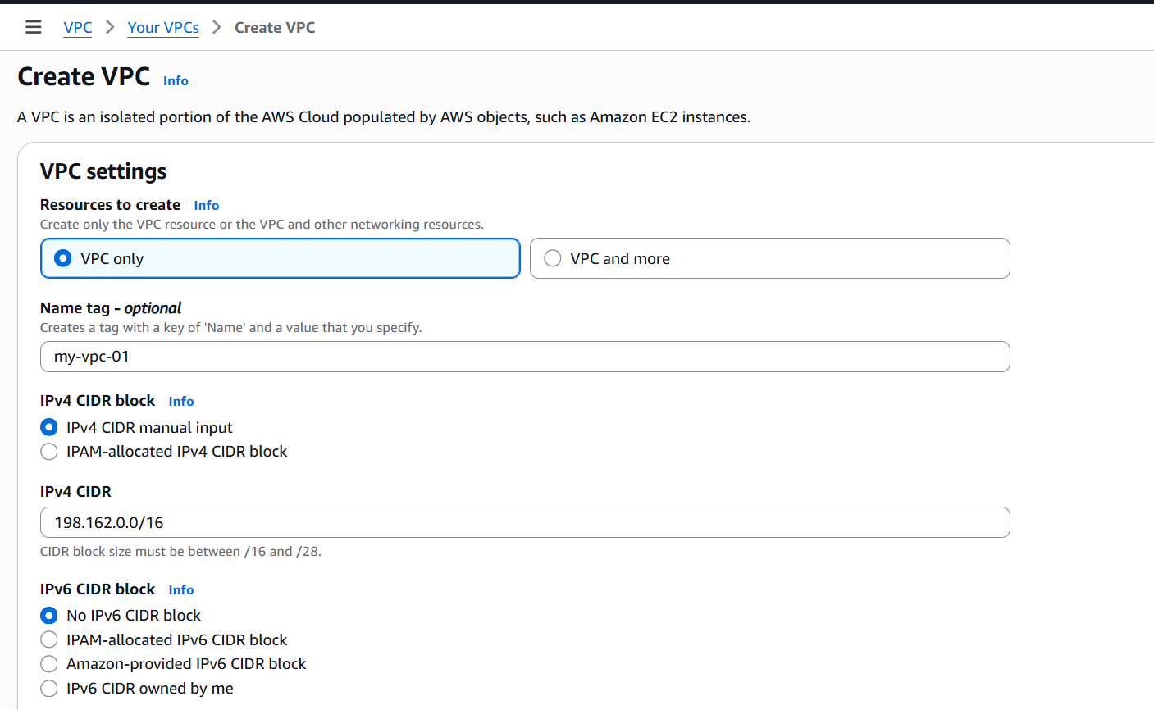

Verify the details and click on create. VPC created.

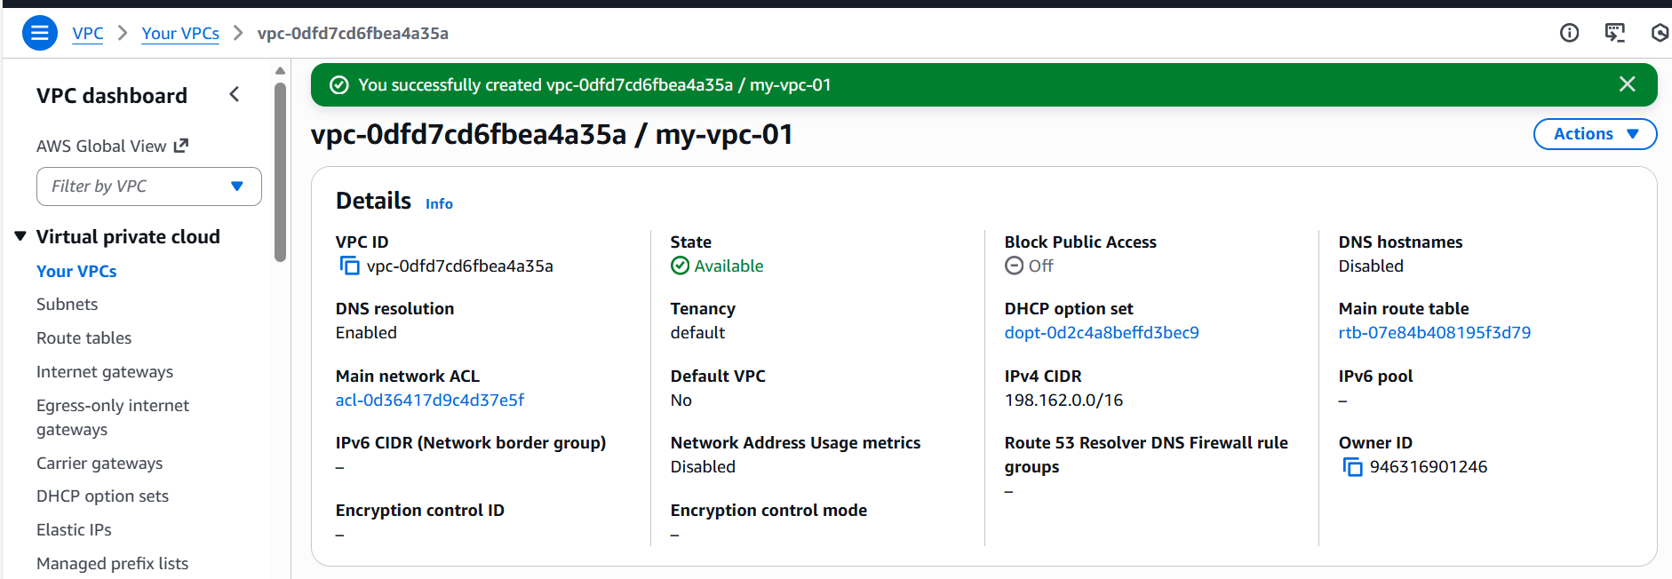

**2.Create two subnets: one public subnet and one private subnet:**

Public subnet created.

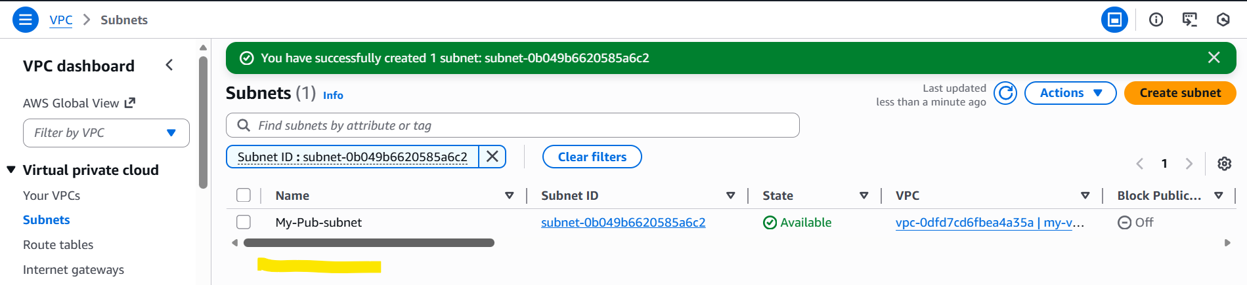

Created private subnet.

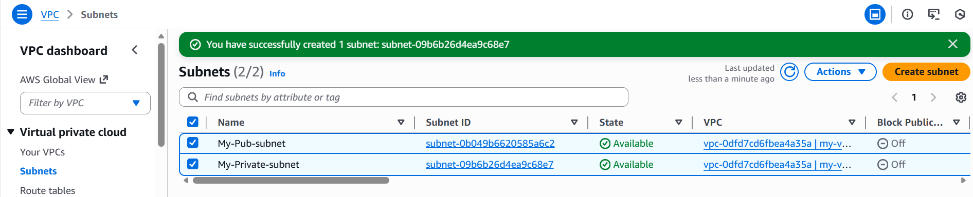

**3.Attach an IGW to the VPC:**

Now my IGW is created.

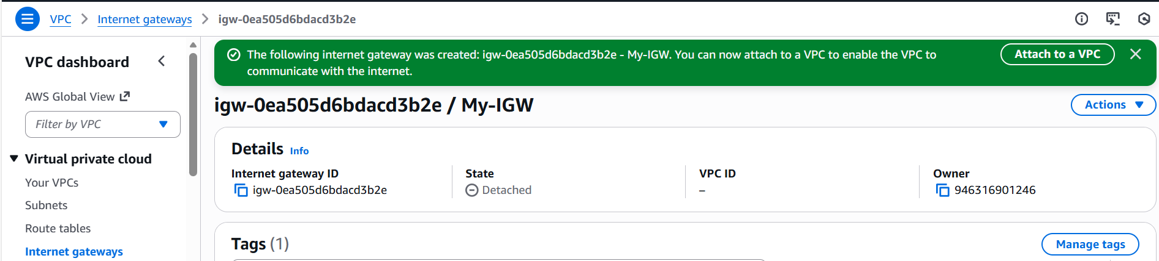

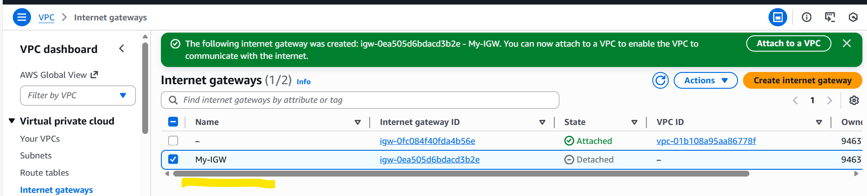

Now we need to attach the IGW to my VPC.

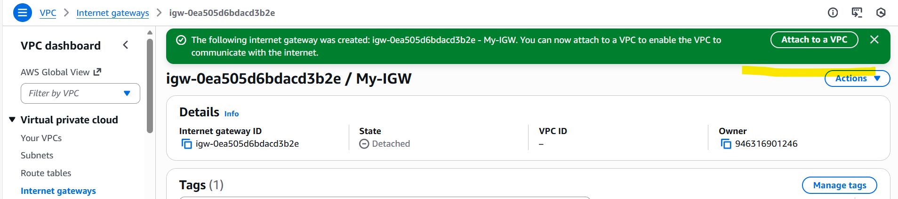

Selected my VPC to attach.

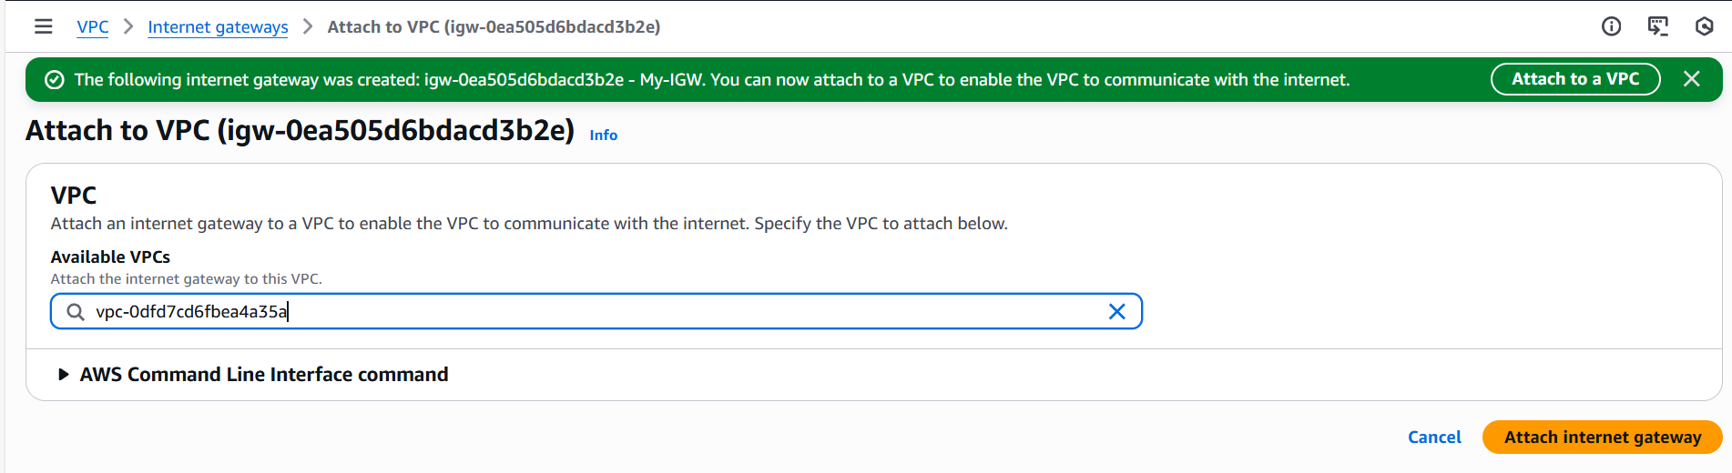

Now, we can see our VPC attached to the IGW.

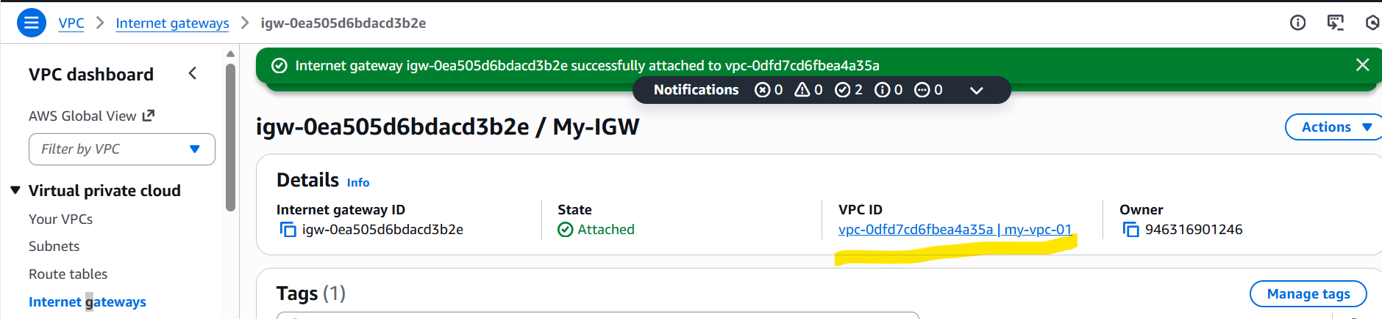

**4.Create one public route table (RT) and one private route table:**

Create a route table to get started. 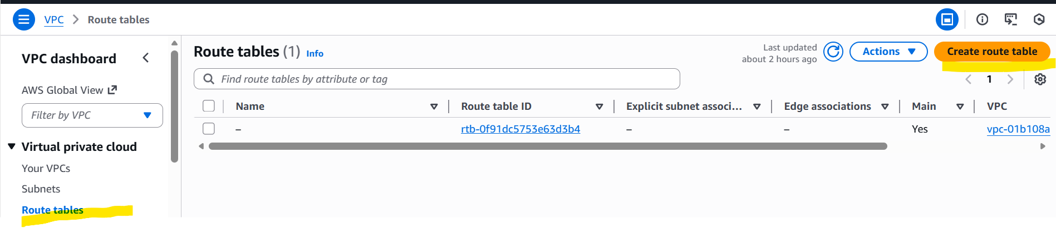

Name the route table as per the requirement. Below is my public route table.

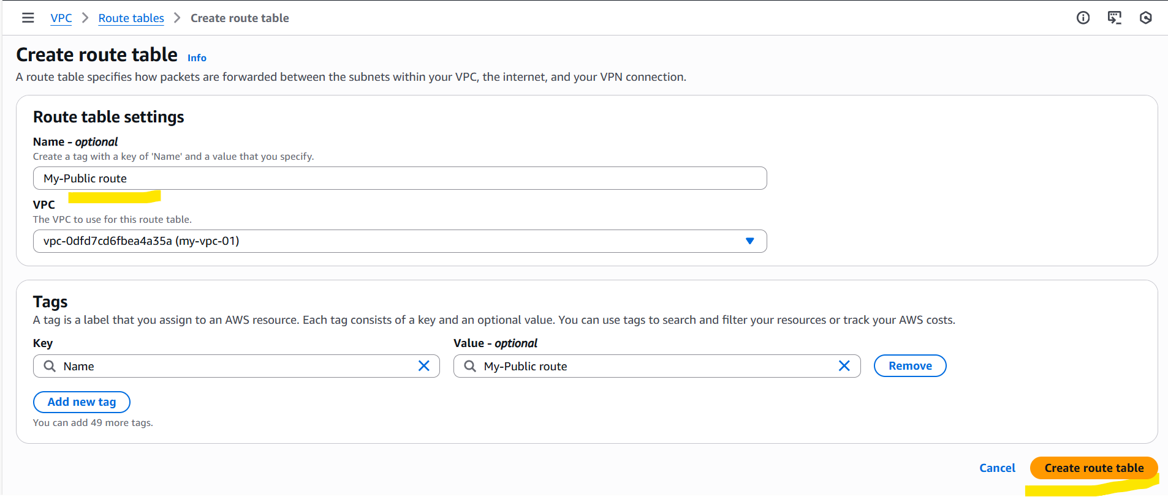

Now my public route is created successfully.

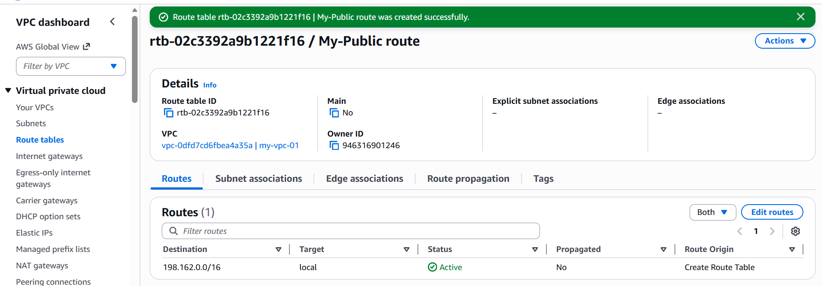

Now we need to got to the Edit subnet associations and select the subnet to map the destination.

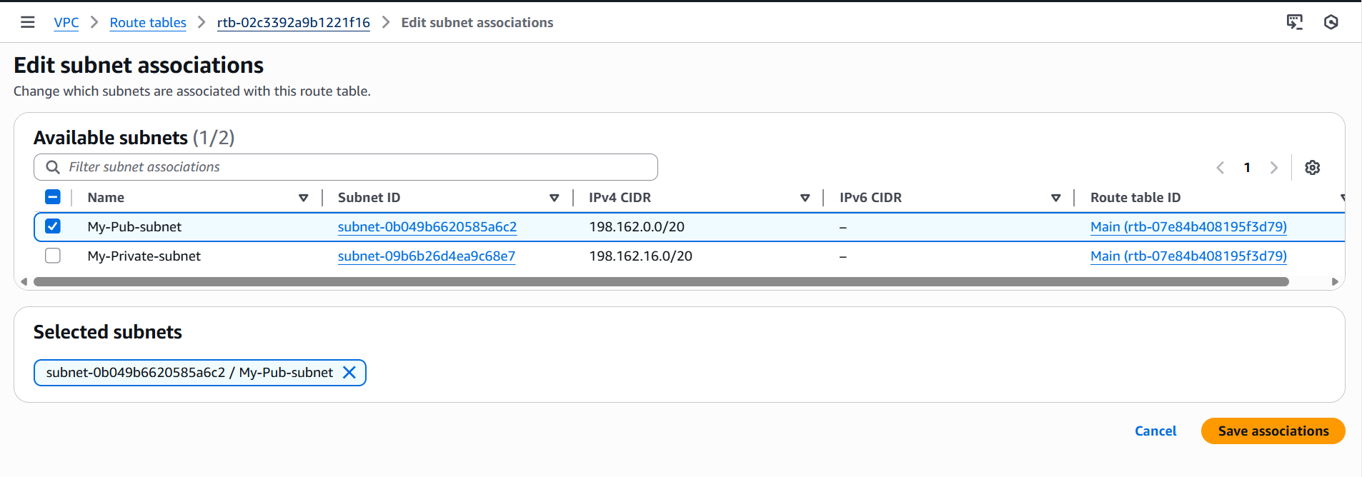Now, let’s create a private route as our next step.

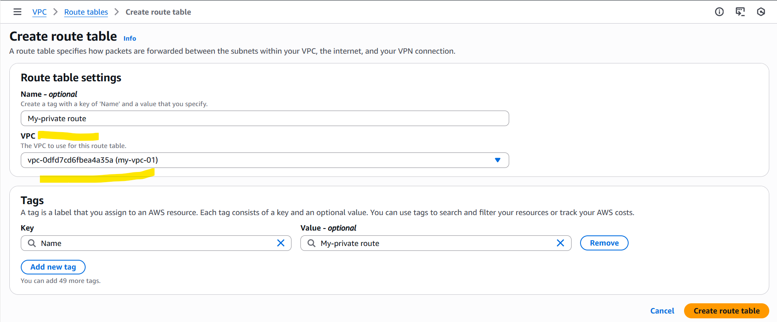

Once the route created, Edit subnet association is updated with private subnet.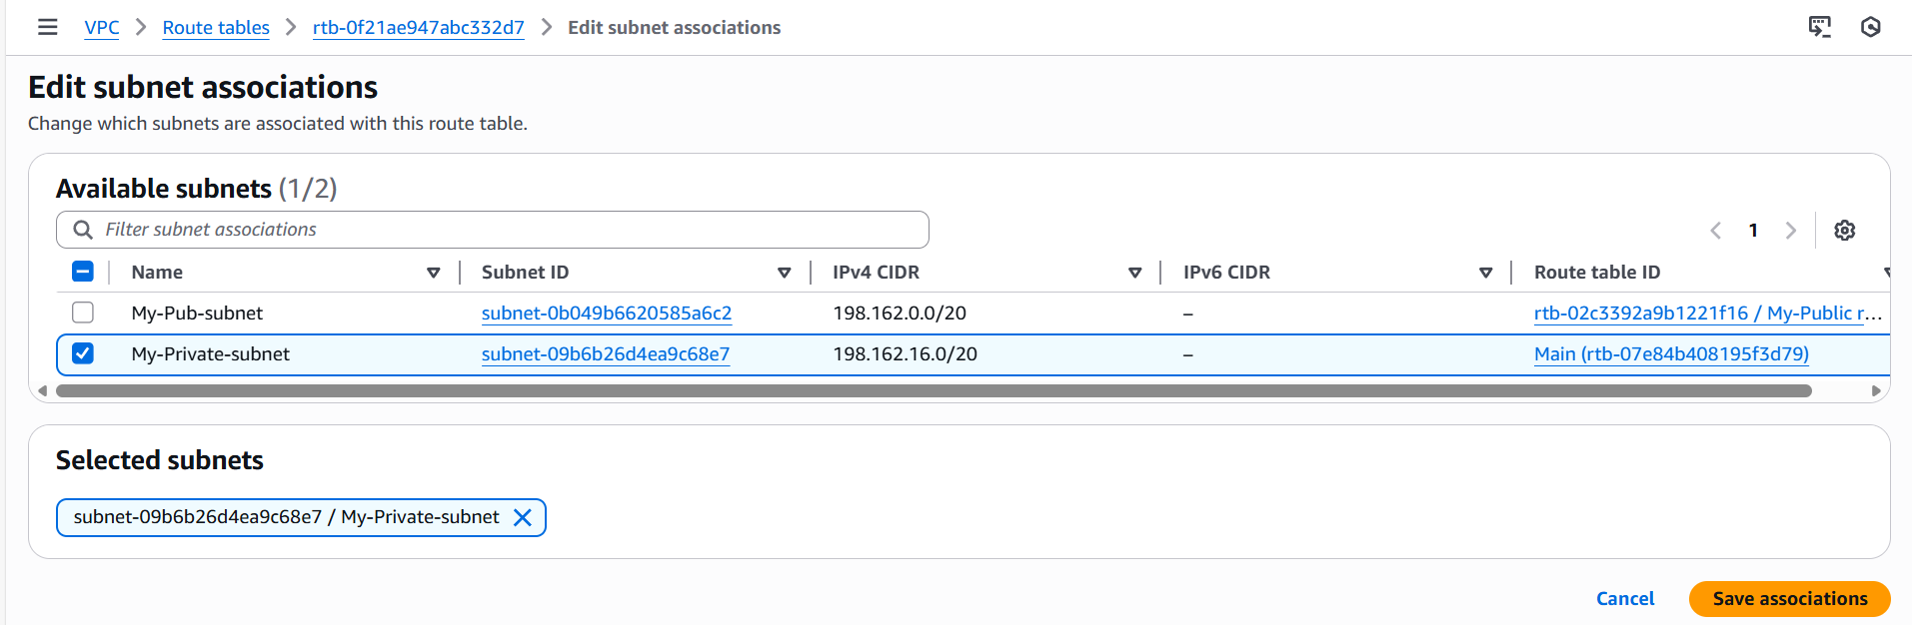

Now the Public route and Private route is updated with our VPC.

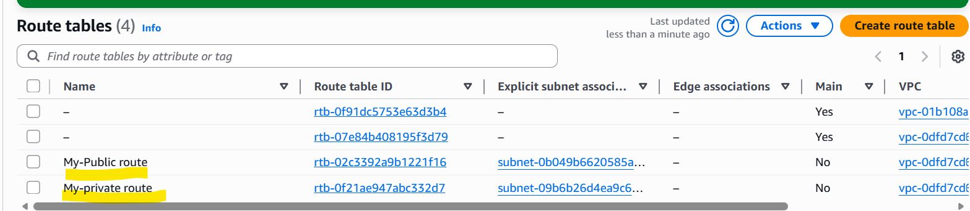

**5.Deploy a NAT gateway in the public subnet and attach the NAT gateway to the private subnet:**

Navigate to VPC and scroll down to left and select NAT gateway and click Create NAT gateway.

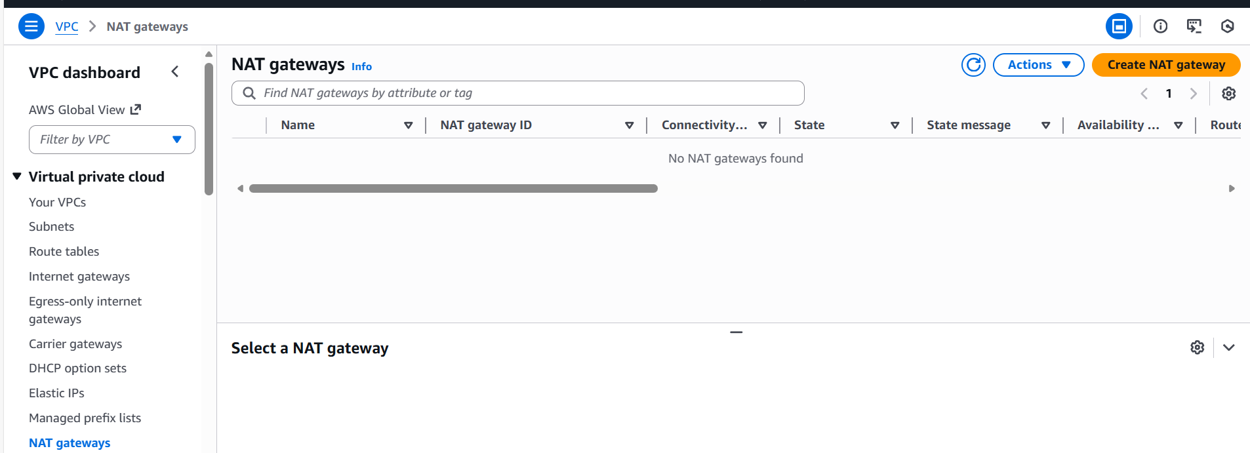

Name the NAT gateway and Availability mode should be Zonal if we need to connect with Private instance.

Attach the public subnet created earlier.

Connectivity type should be Public as well.

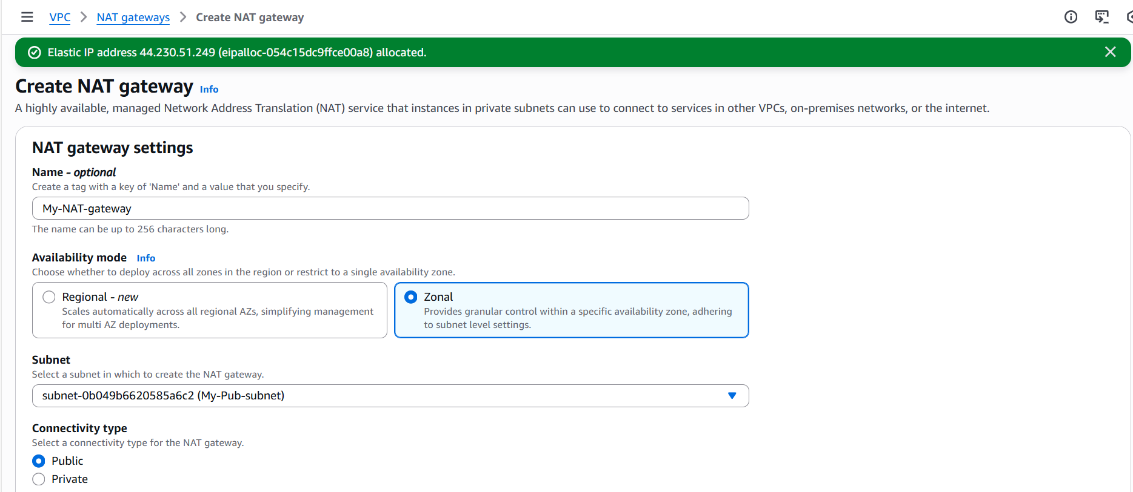

One Elastic Ip has been allocated, so that our IP will be fixed and it will not be removed from our VPC.

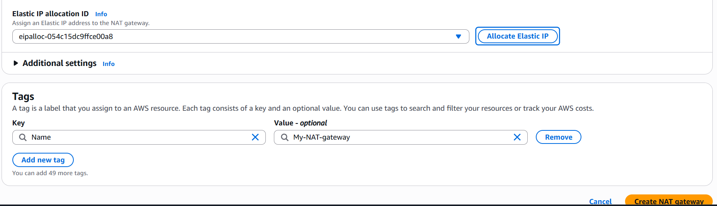

Nat gateway created successfully.

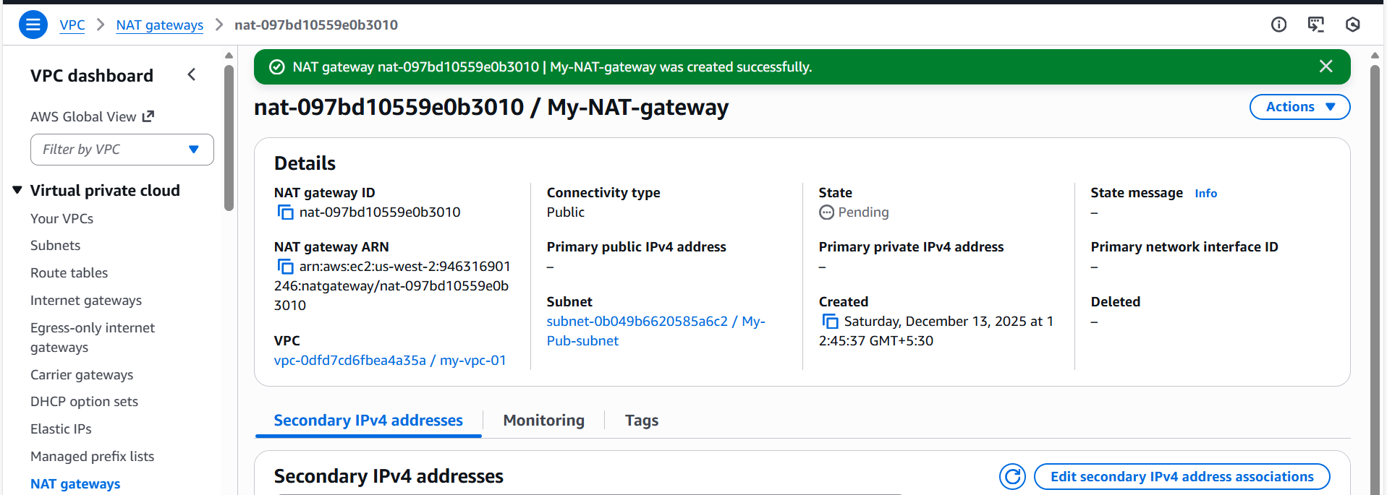

**Step 7:** NAT attached successfully.

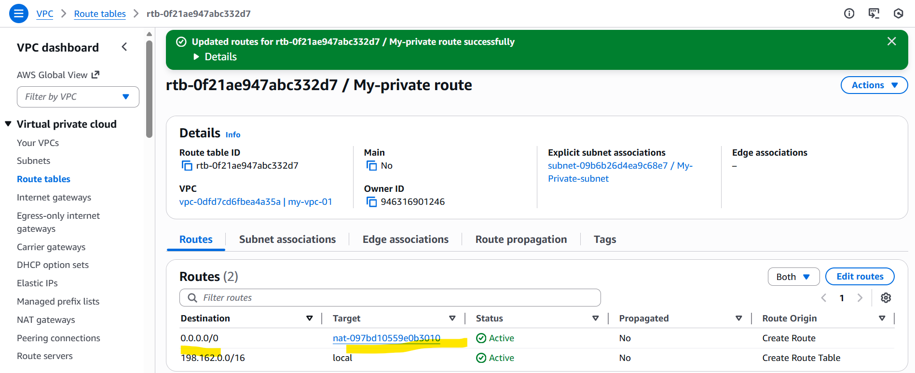

**6.Create two instances, one in the public subnet and one in the private subnet.**

Launching 1st instance with public subnet.

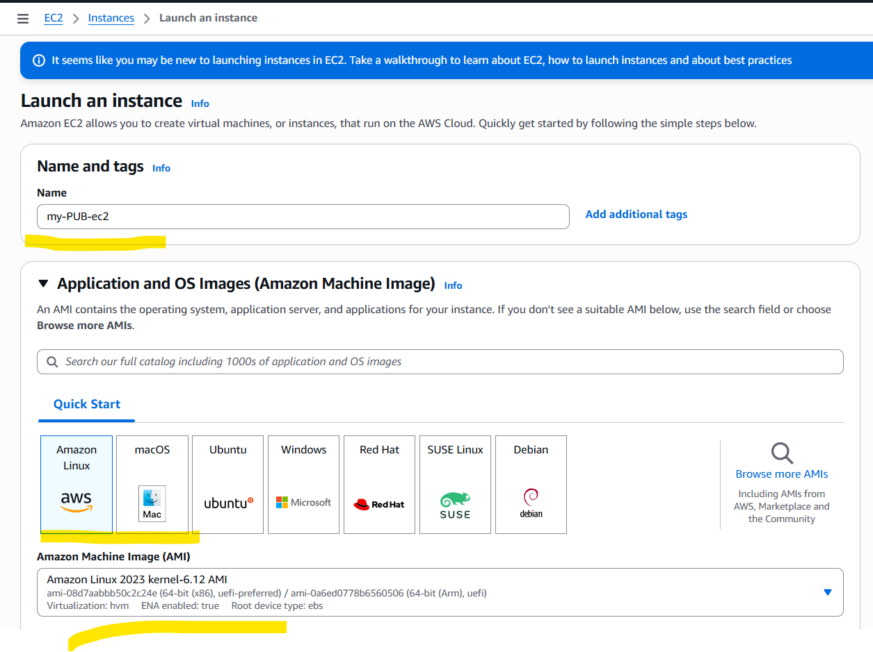

As per the requirement, attached VPC and public subnet created earlier.

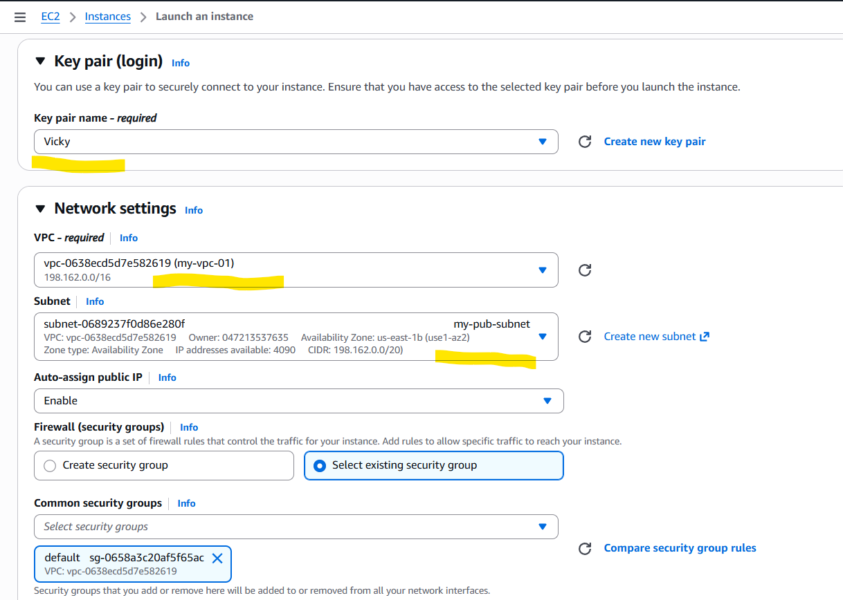

Instance launched successfully with public subnet.

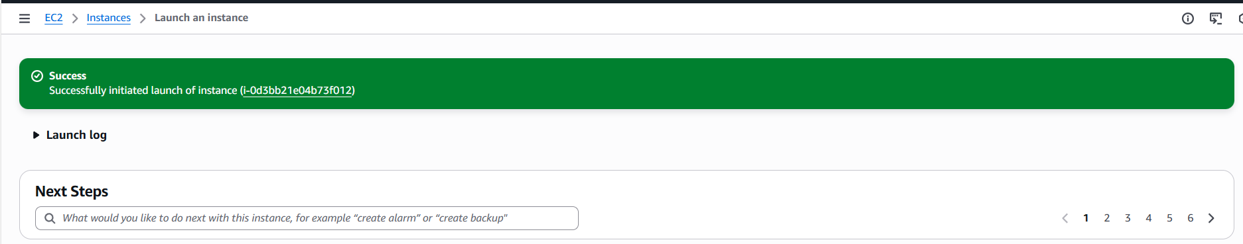

Launching our second instance with private subnet.

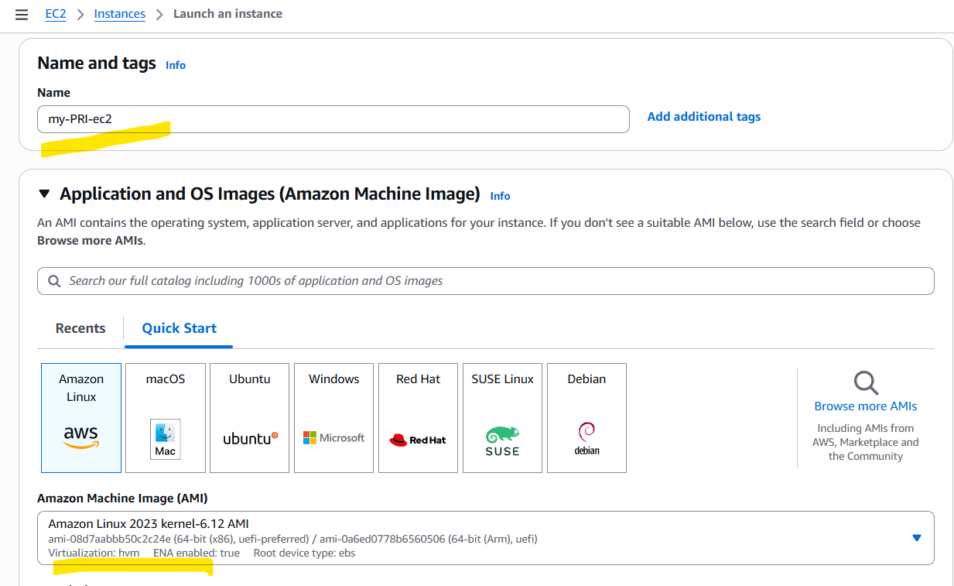

Attached private subnet which doesn’t has internet gateway.

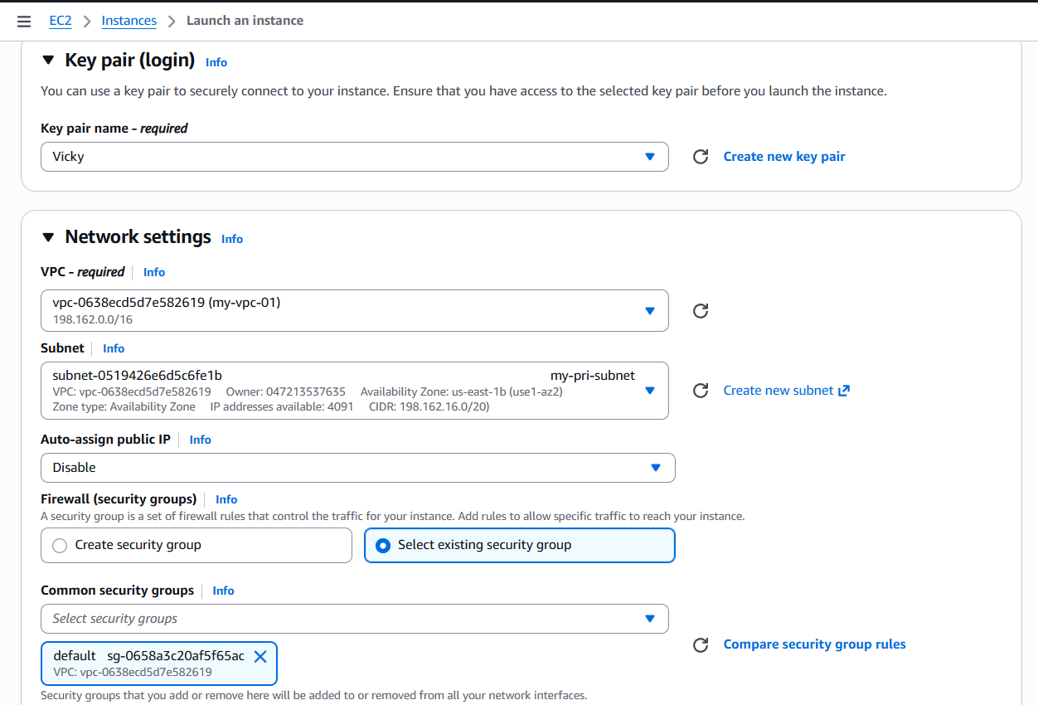

Instance launched successfully with private subnet.

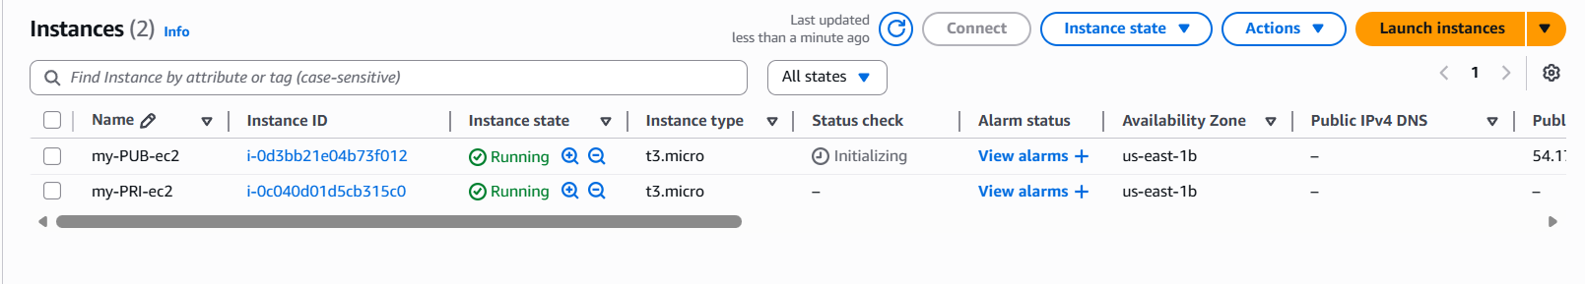

**7.Deploy Apache server on both EC2 instances with a sample index.html file:**

Let’s get connected with public ec2 to install HTTPD package.

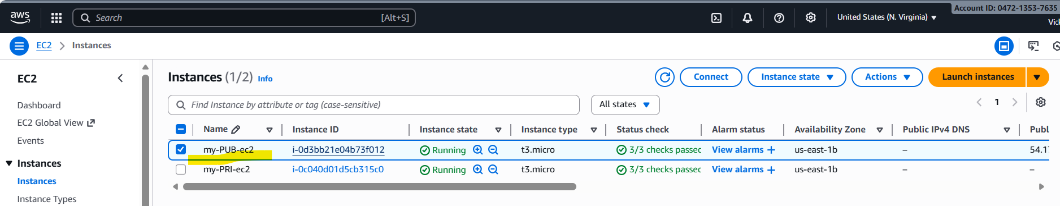

Copied the ssh and connecting from git application.

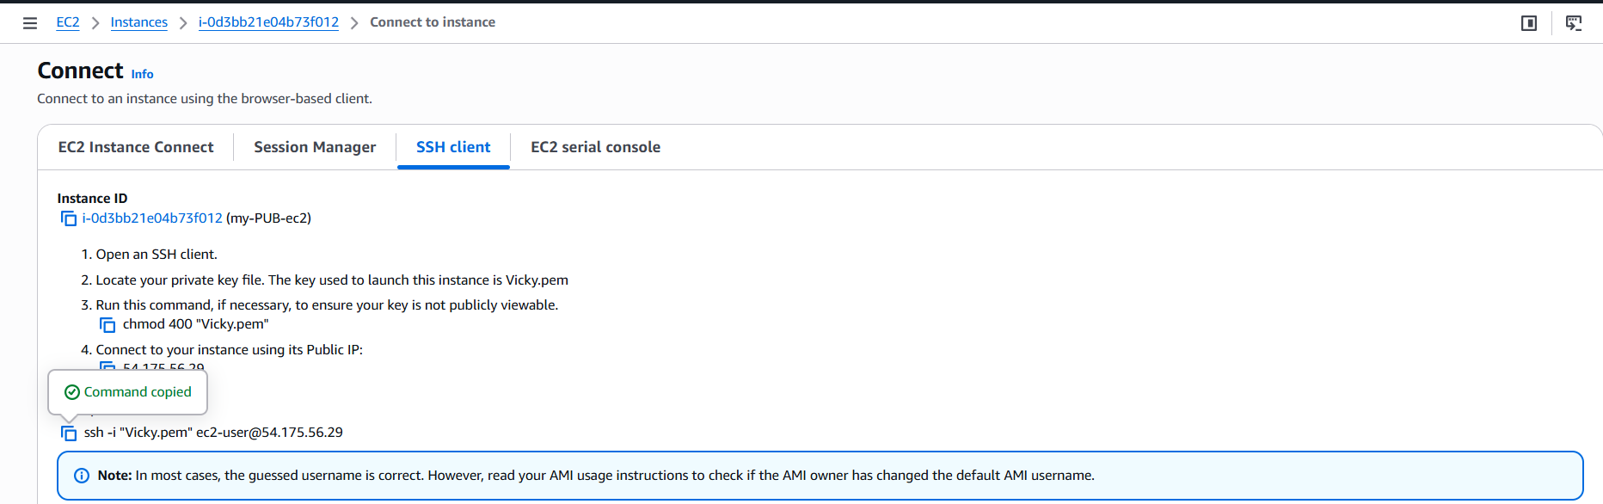

Success. We were able to get connected to the public subnet with ec2 (CLI)

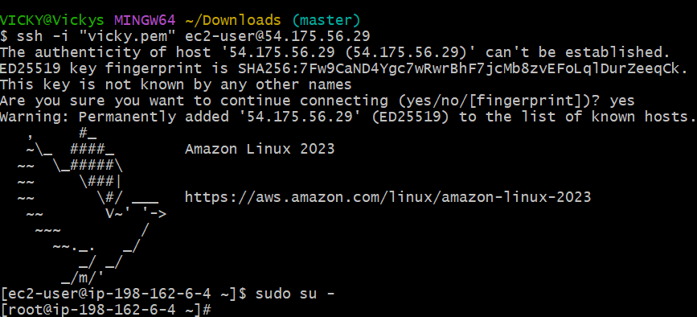

Install Apache package (httpd)- yum install httpd -y

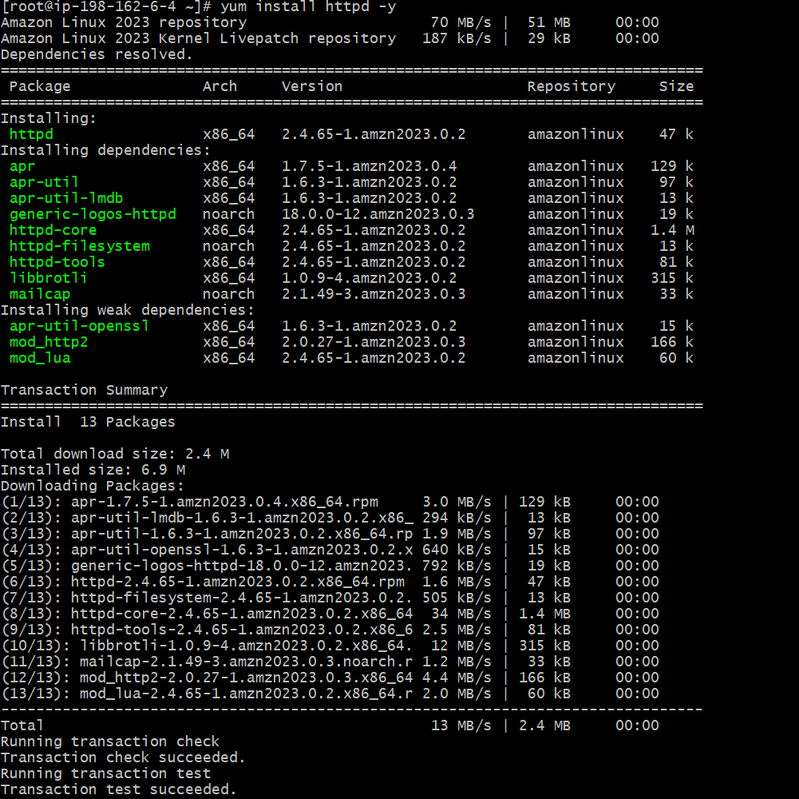

Verify the status and start the package.

Success- the package has started successfully and active status.

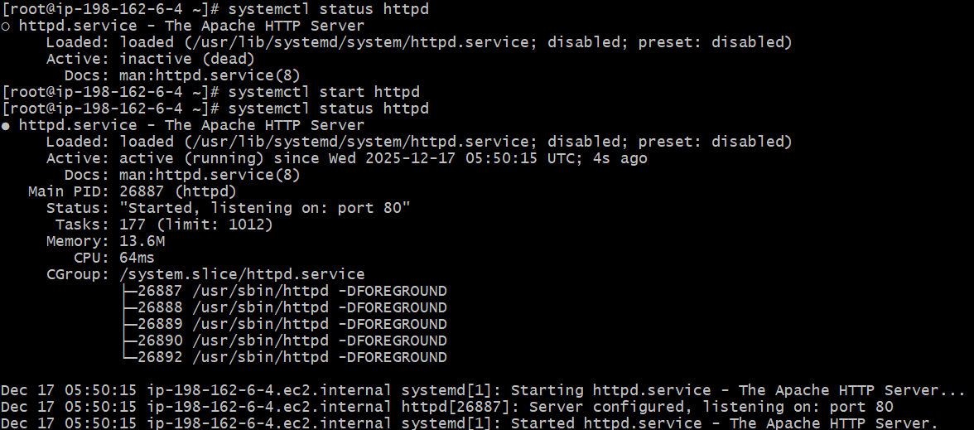

Now, it’s time to verify on the browser as well with Public ip.



Now, we need to create a index.html file and insert the below data to test if Apache server is working.

Change the directory to /var/www/html

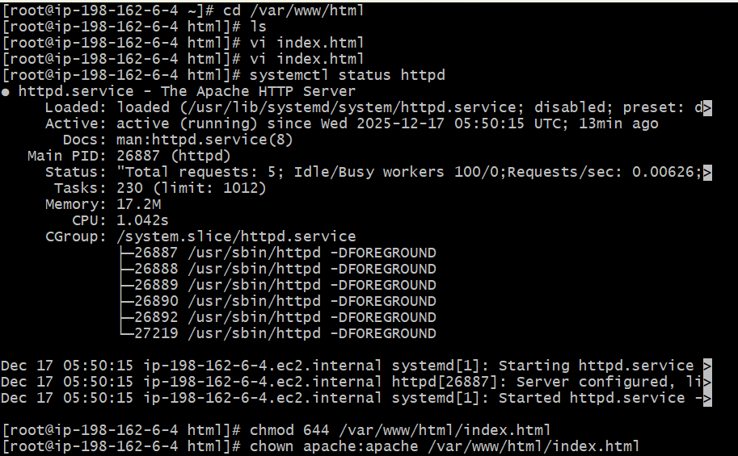

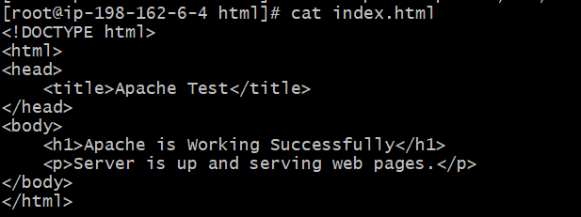

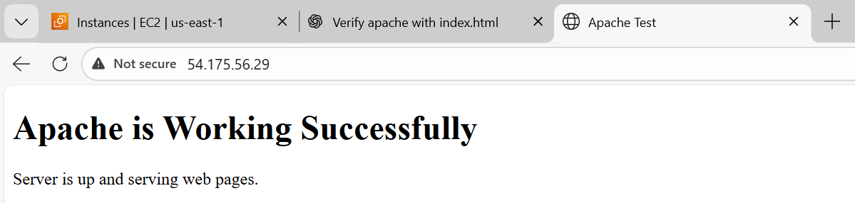

Let’s try connecting with second ec2 private IP to connect with Apache server. Of course it will not work, because there is no internet.

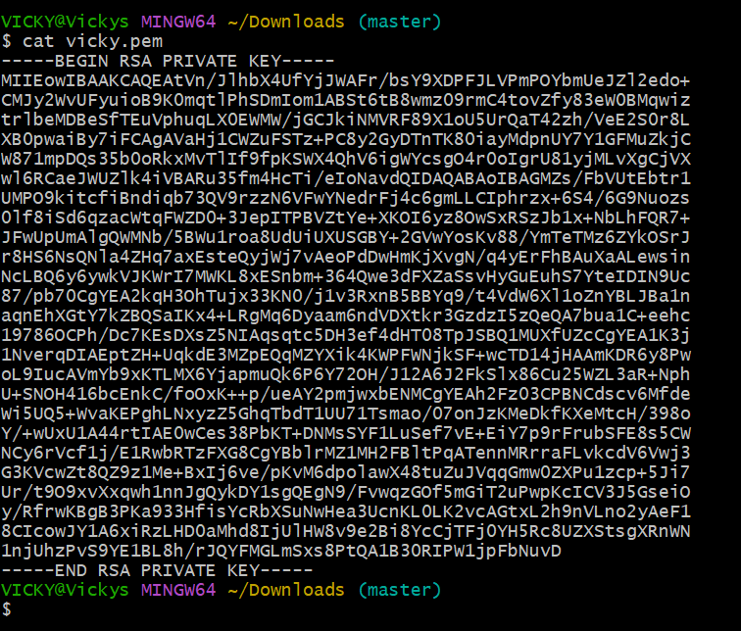

Created a pem using vi test.pem and provided permissions using chmod 600 test.pem.

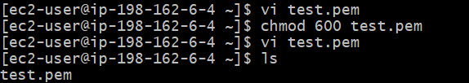

Now, let’s connect with second ec2 private ip and verify if the connection is successful

Let’s ping internet as well to verify if the NAT is providing outbound access.

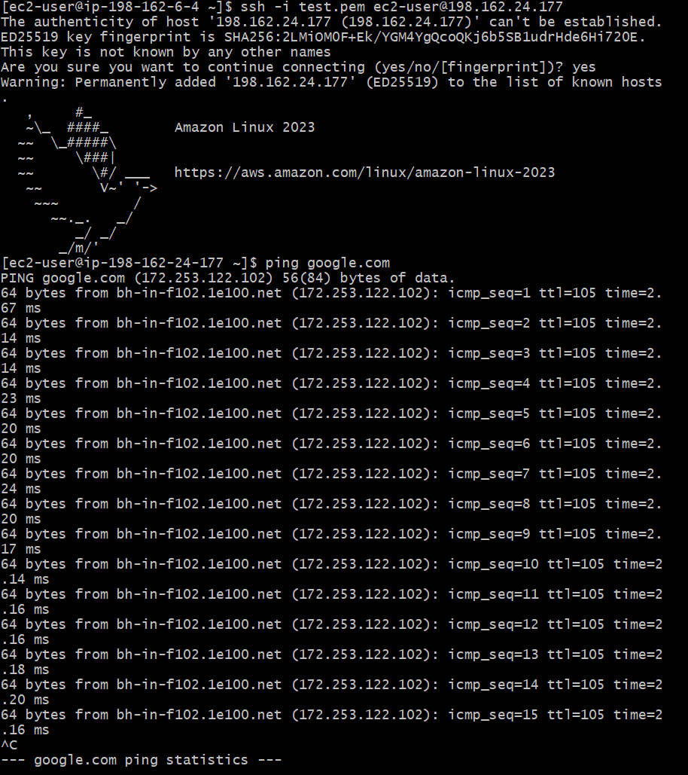

Now let’s install Apache server in private ec2 as well.

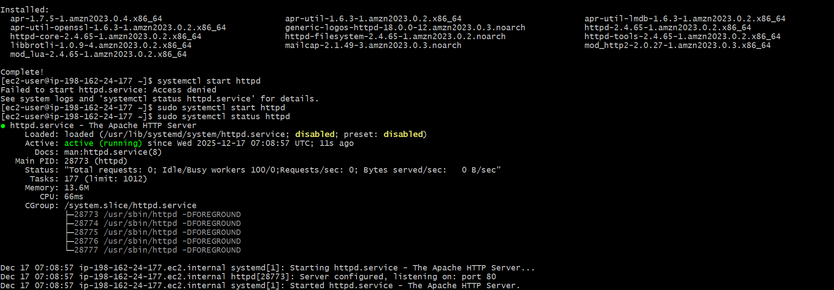

Now, let’s change the directory and create a index.html.

Provide permissions- chmod 644 index.html

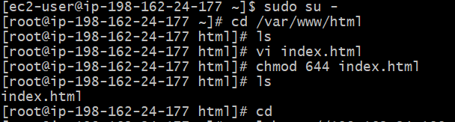

Verified in CLI if Apache is working using command**- curl** [**http://198.162.24.177:80**](http://198.162.24.177:80)**. Success.**



**8.Create one application load balancer and attach it to both EC2 instances:**

Create a new subnet in a different zone and with the same CIDR range which our VPC is attached.

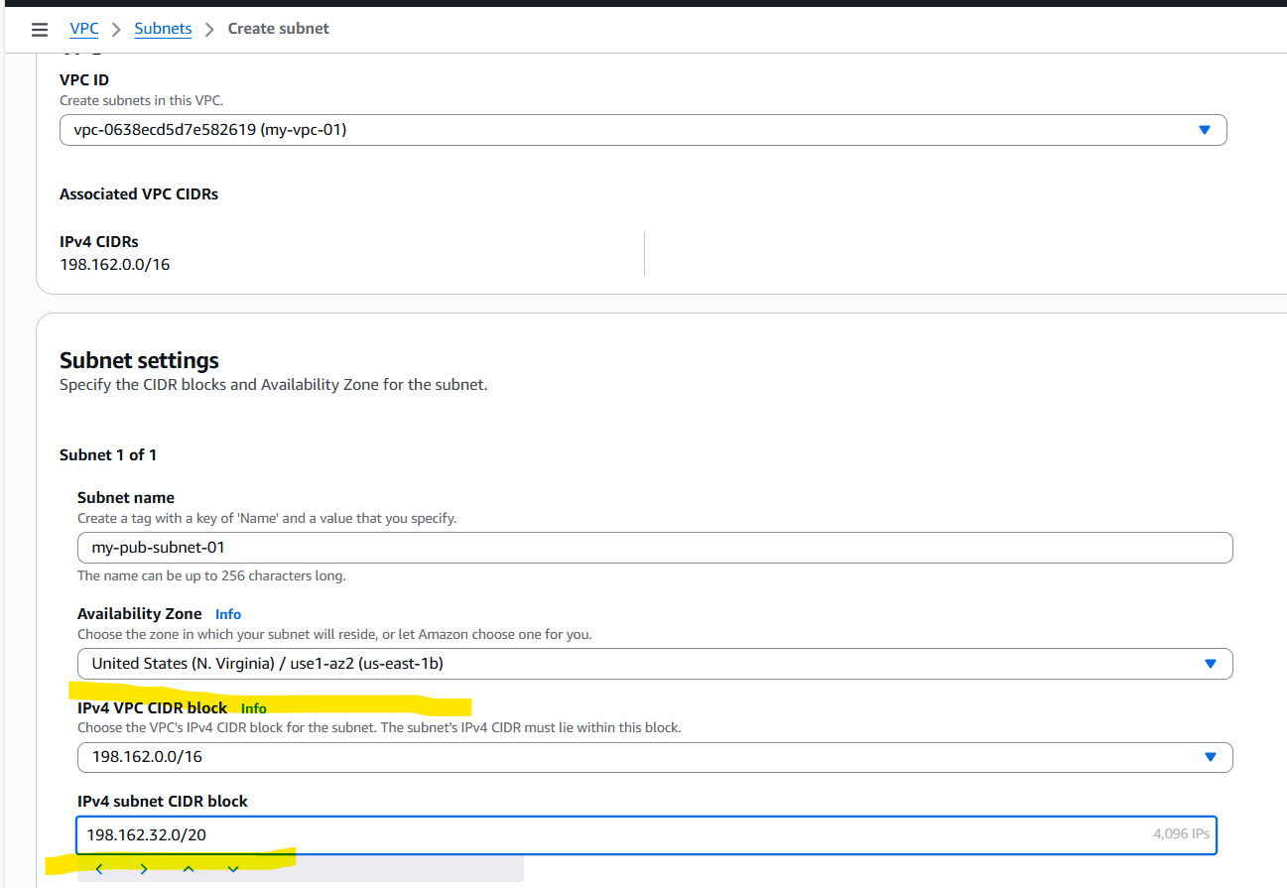

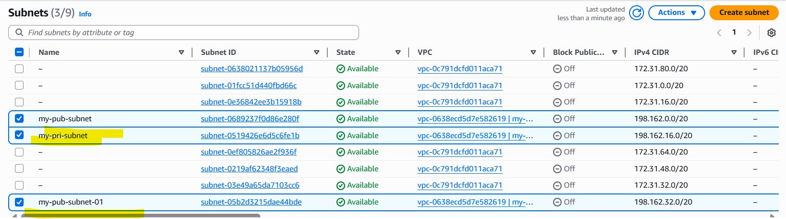

In public route table, navigate to Subnet associations and attach the newly created subnet. 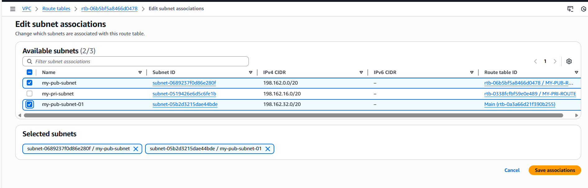

Attached two pub subnets to the public route table.

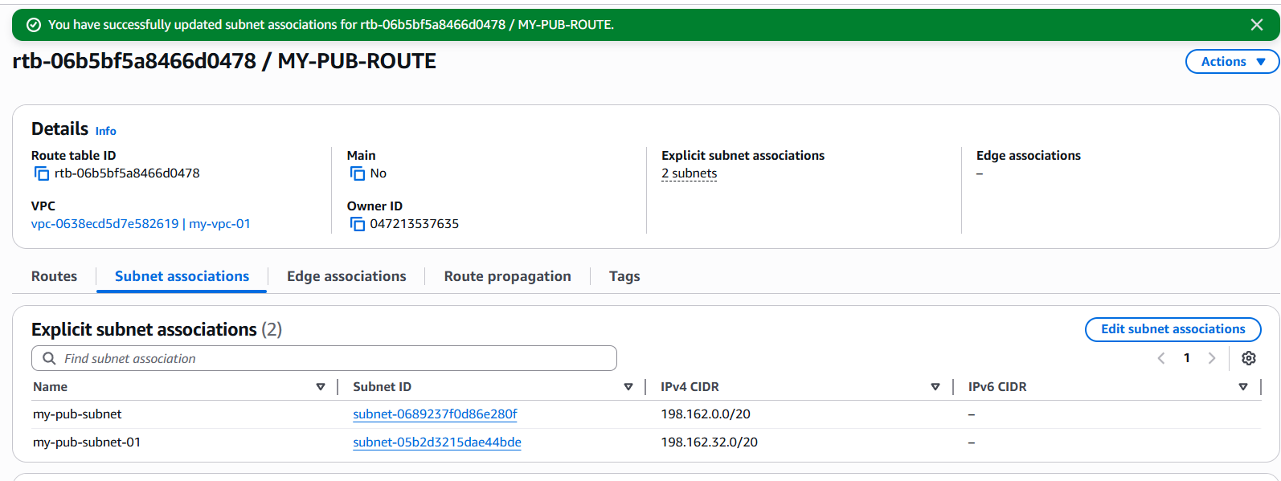

Navigate to ec2 and select Load balancer as a service and create one.

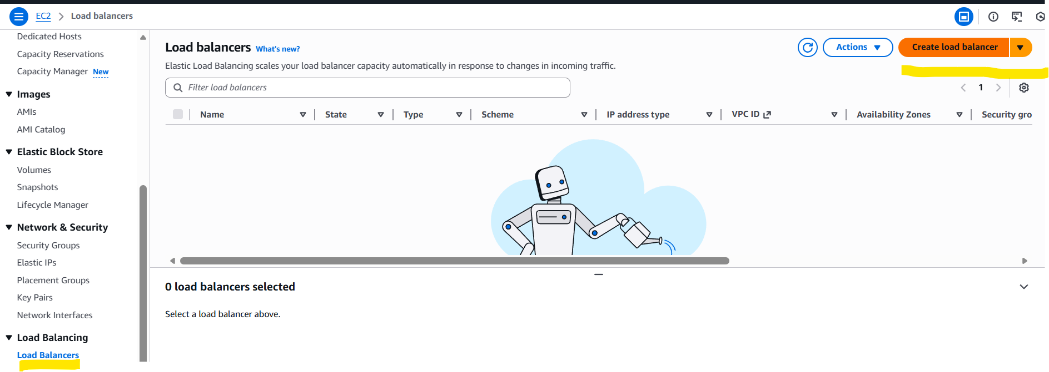

Select Load balancer application as an option

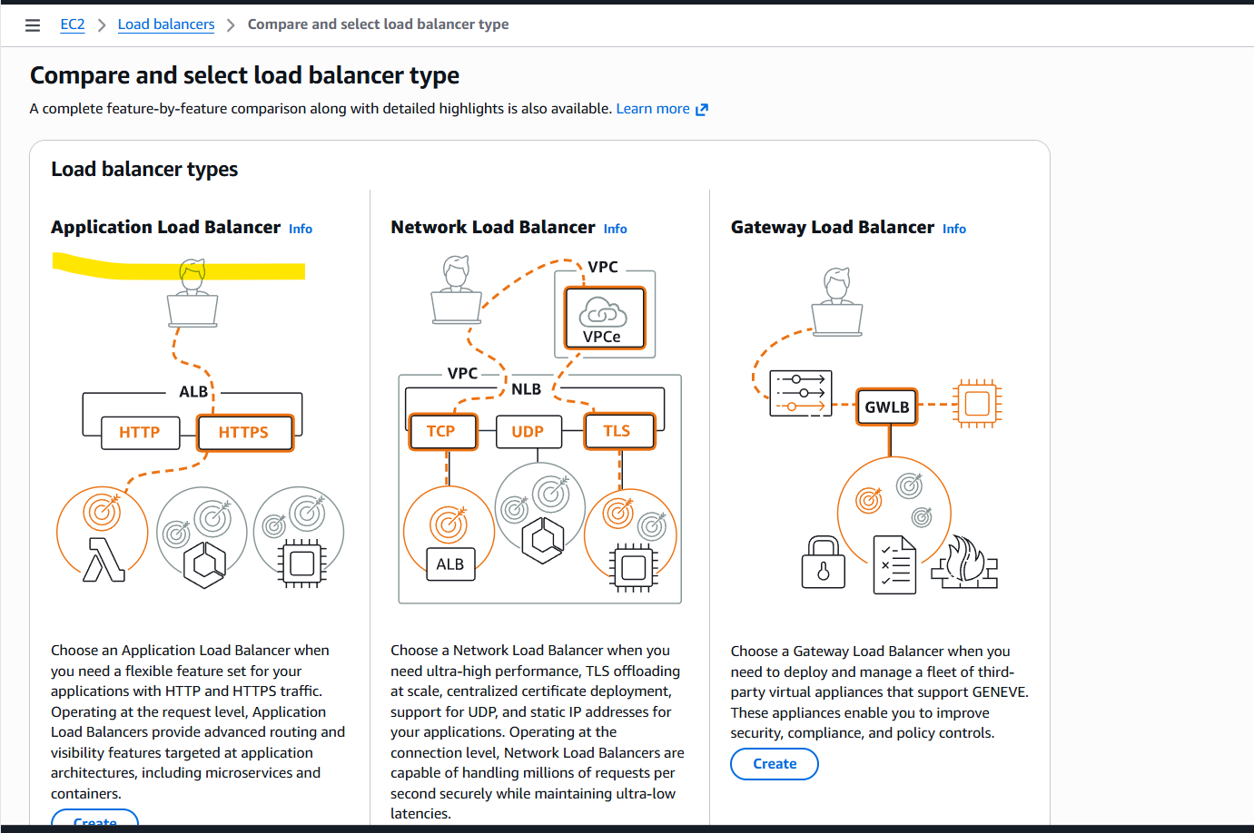

Give a name to the Load Balancer and select- Internet facing as scheme.

Load balancer IP address type is- IPv4

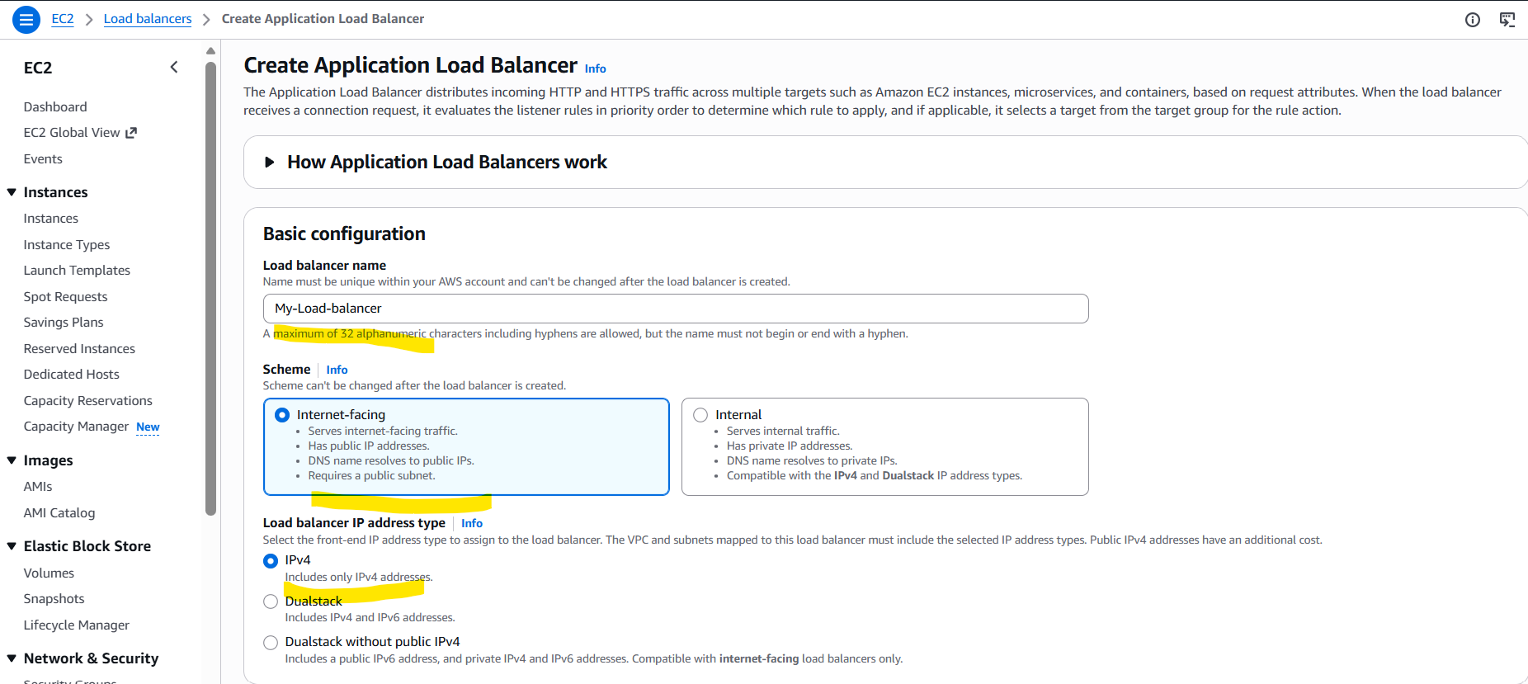

Update network mapping to reflect the VPC and 2 public subnets in 2 different regions

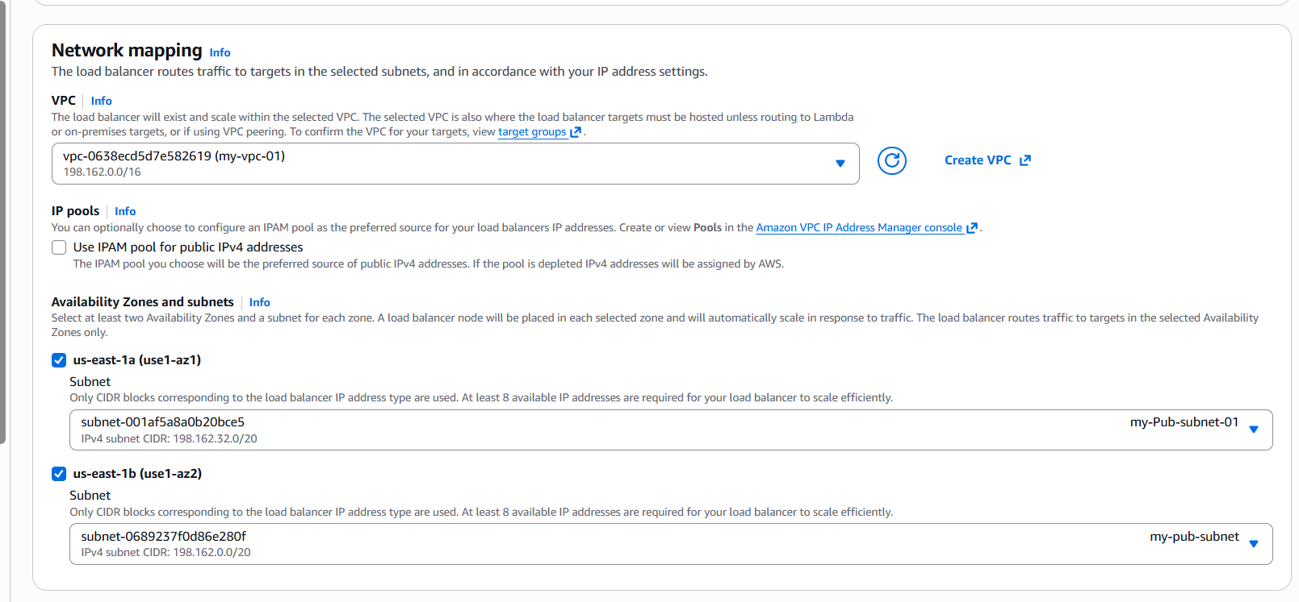

Select the VPC and continue to next.

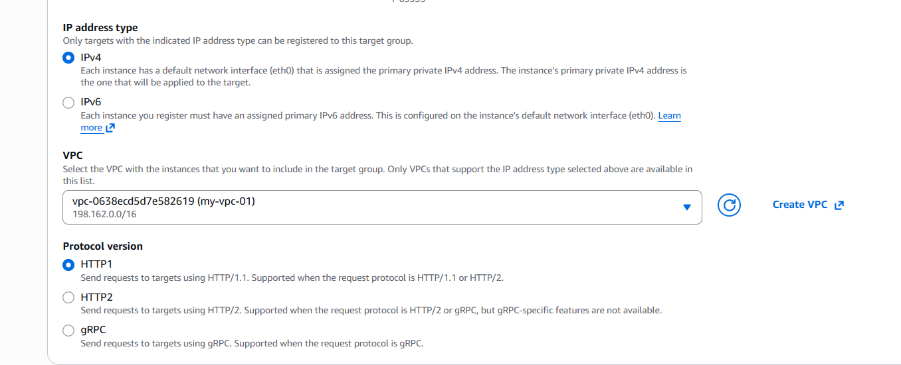

select the two instances running and continue.

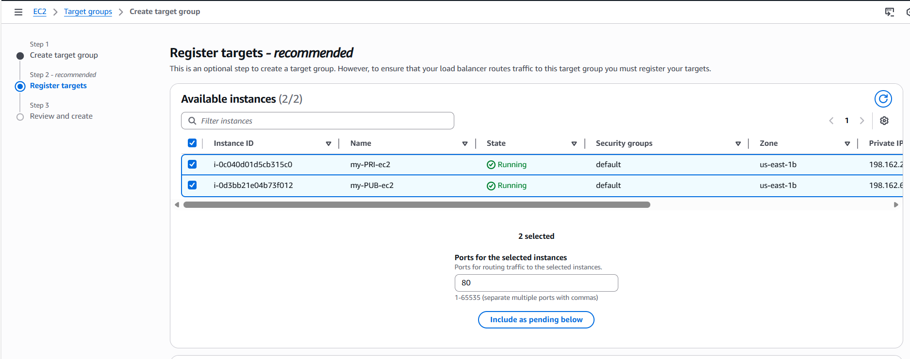Continue and create a new target group.

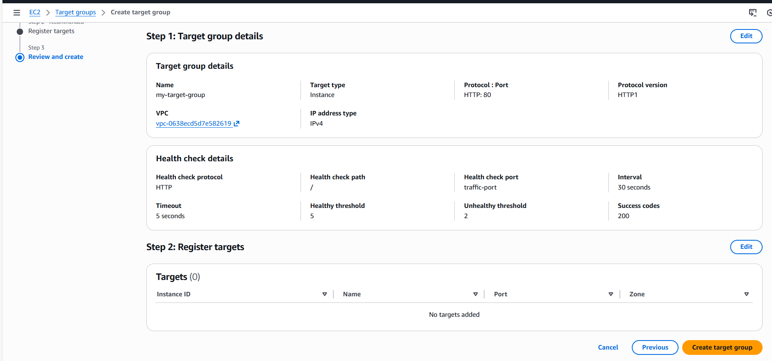

Target groups have been successfully created and health checks are 0.

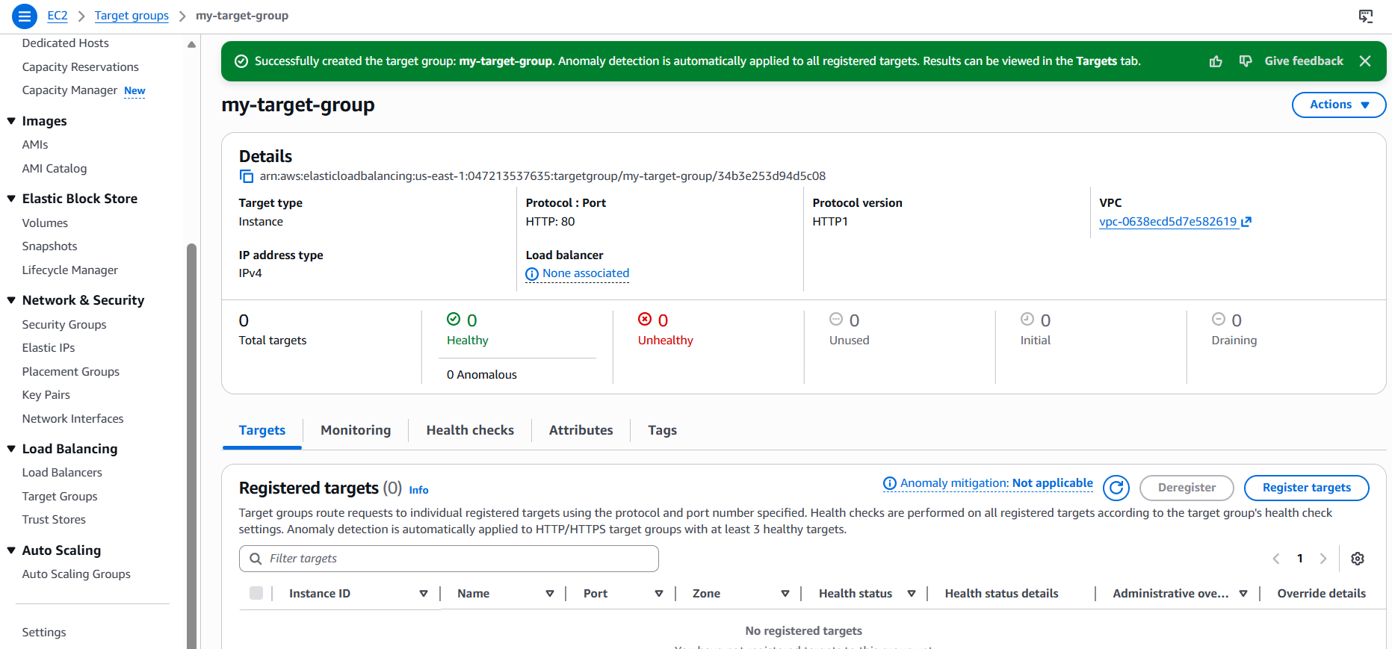

Note: Navigate to Register targets and select the 2 instances if there is an issue while creating the Target groups.

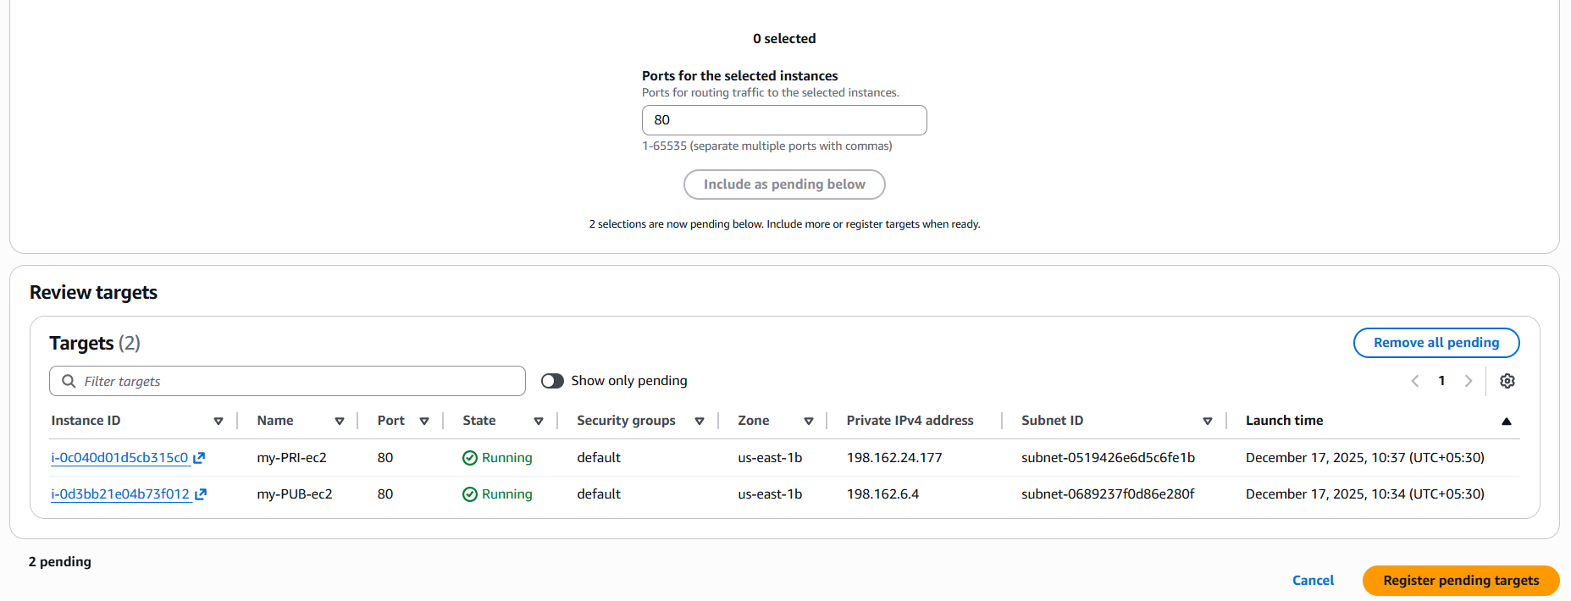

Now back to Load balancer to attach the Target groups created.

We were successfully attach the Target groups and lets go ahead and create the load balancer.

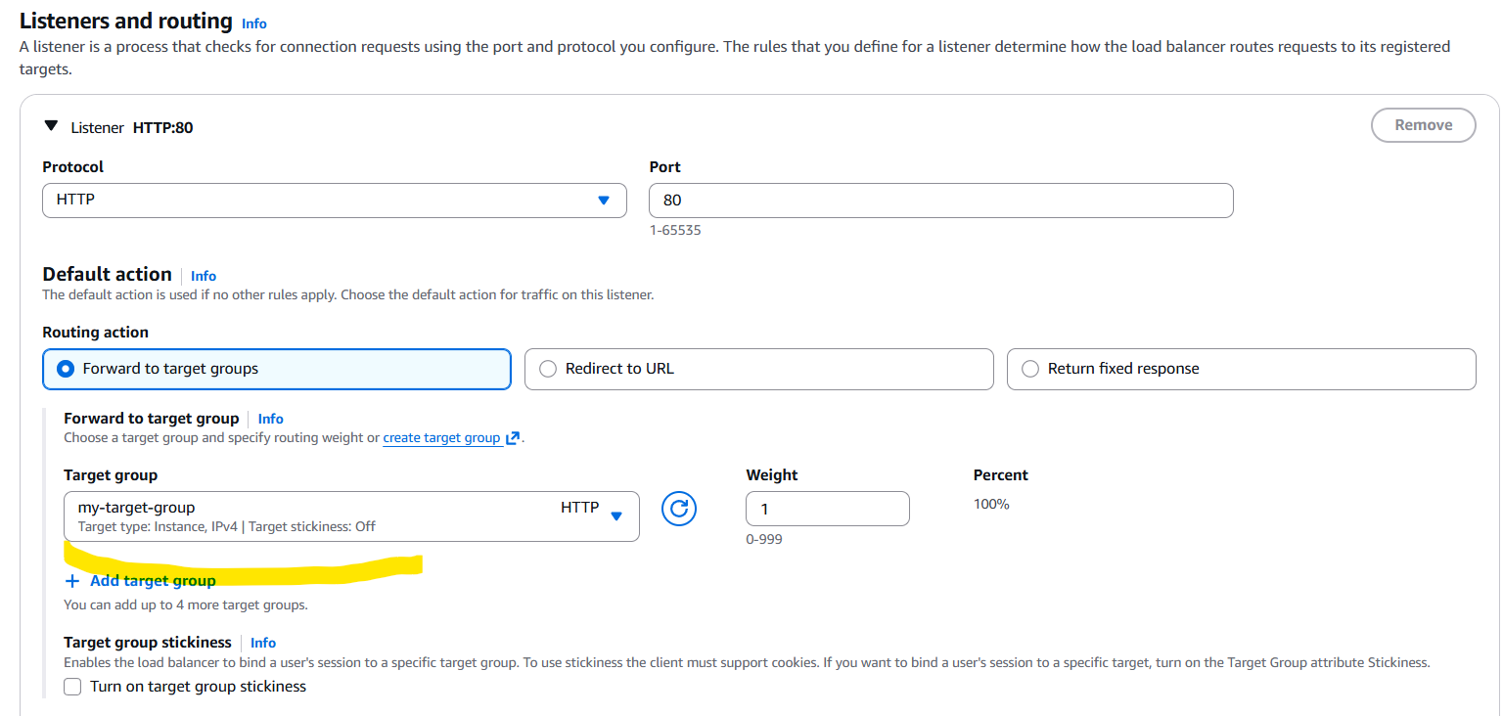

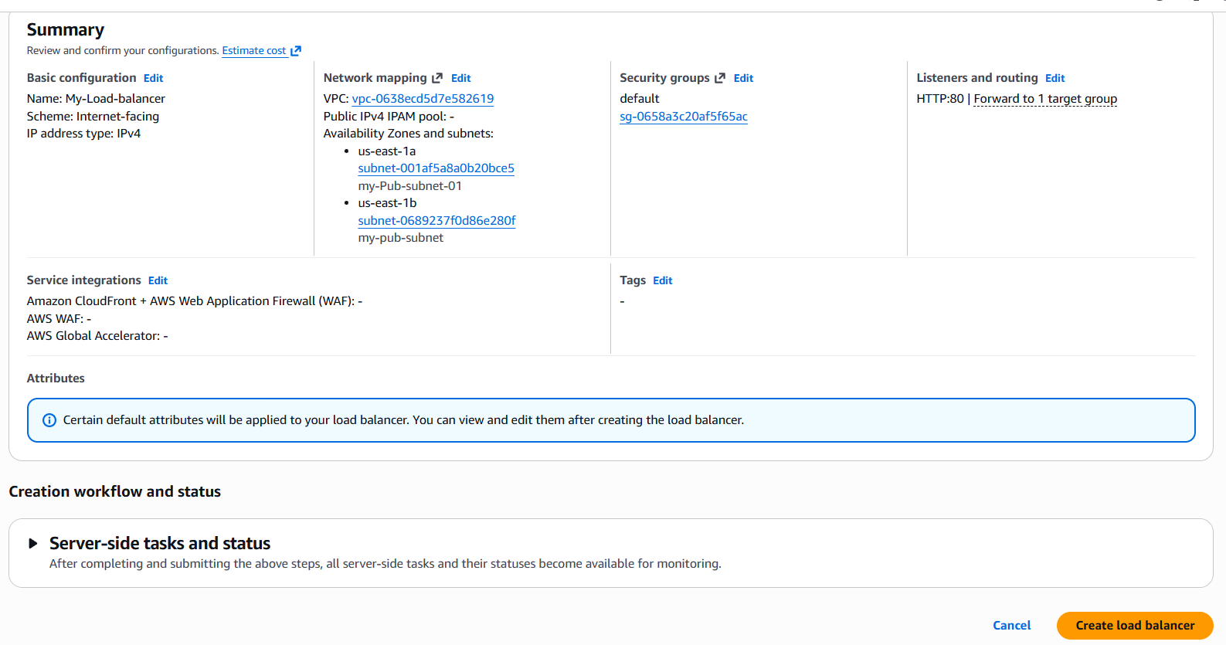

Load balancer created successfully by attaching 2 public subnets and 2 ec2 instances to control the traffic flow for my application Load balancer.

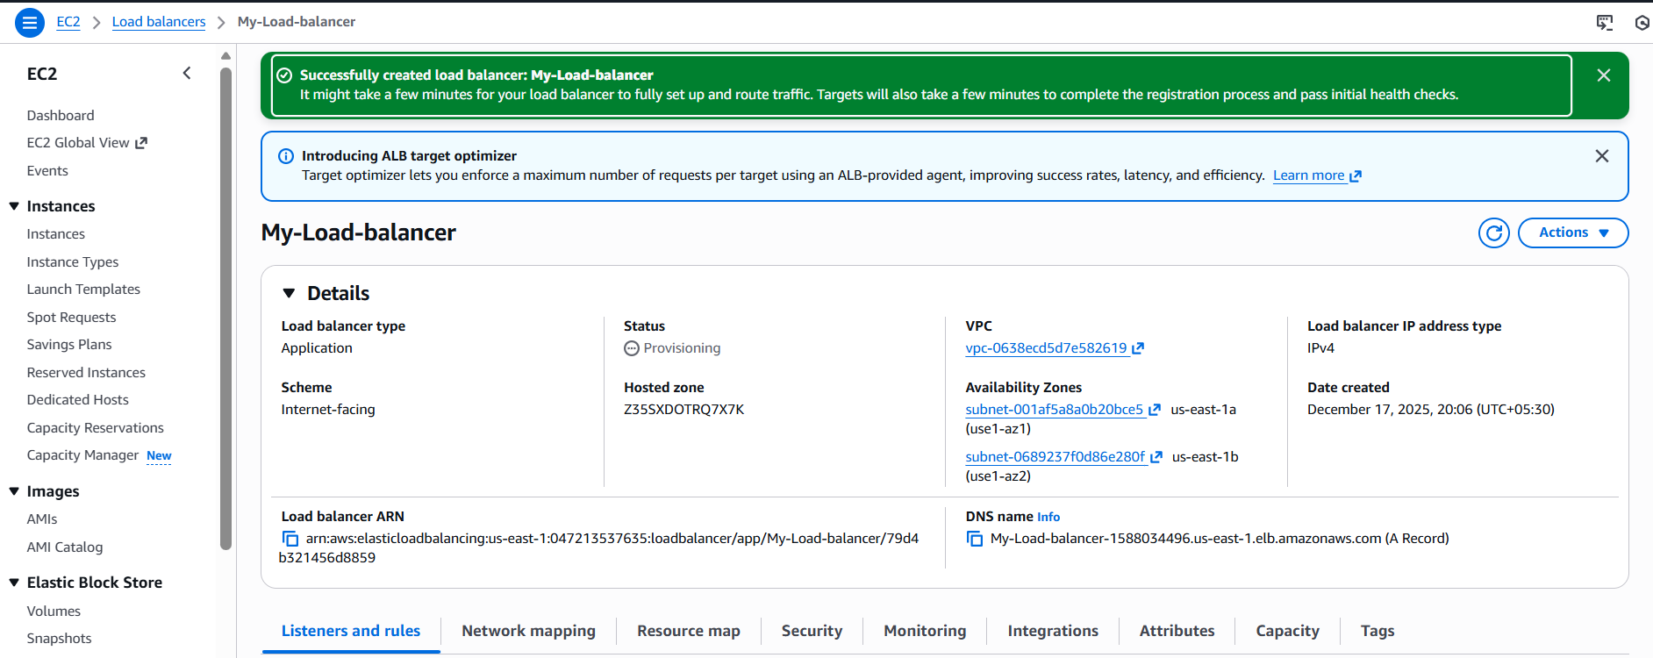

Now its time to verify if the Apache package is working as expected.

Click on the DNS link and copy the link and paste in the browser.

It should display the private instance and once again if you refresh the same page, it should display the public instance.

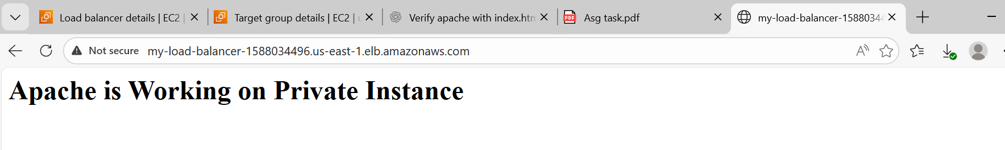

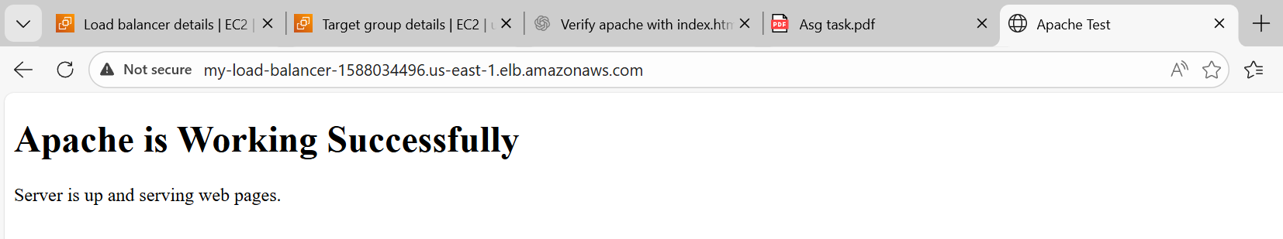

**9.Store application load balancer logs in S3:**

Navigate to s3 and create a bucket with all defaults and no changes.

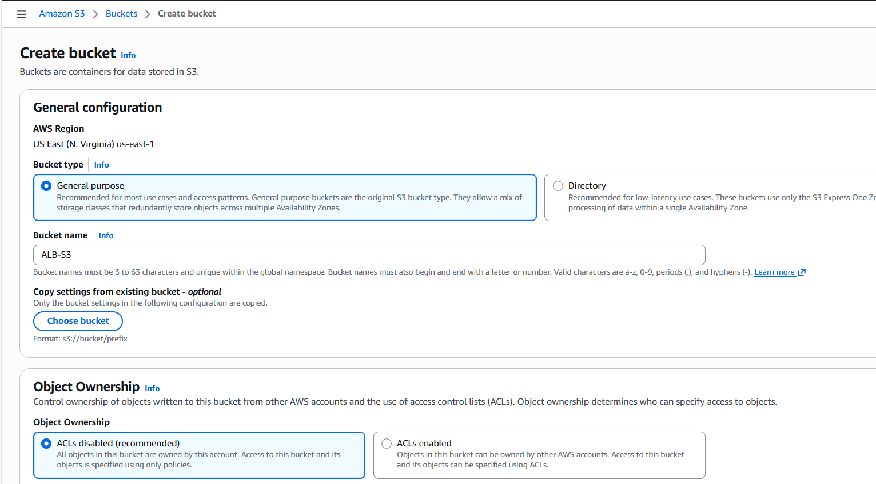

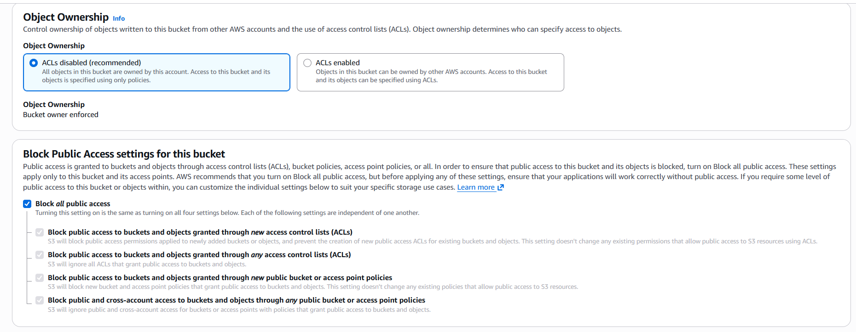

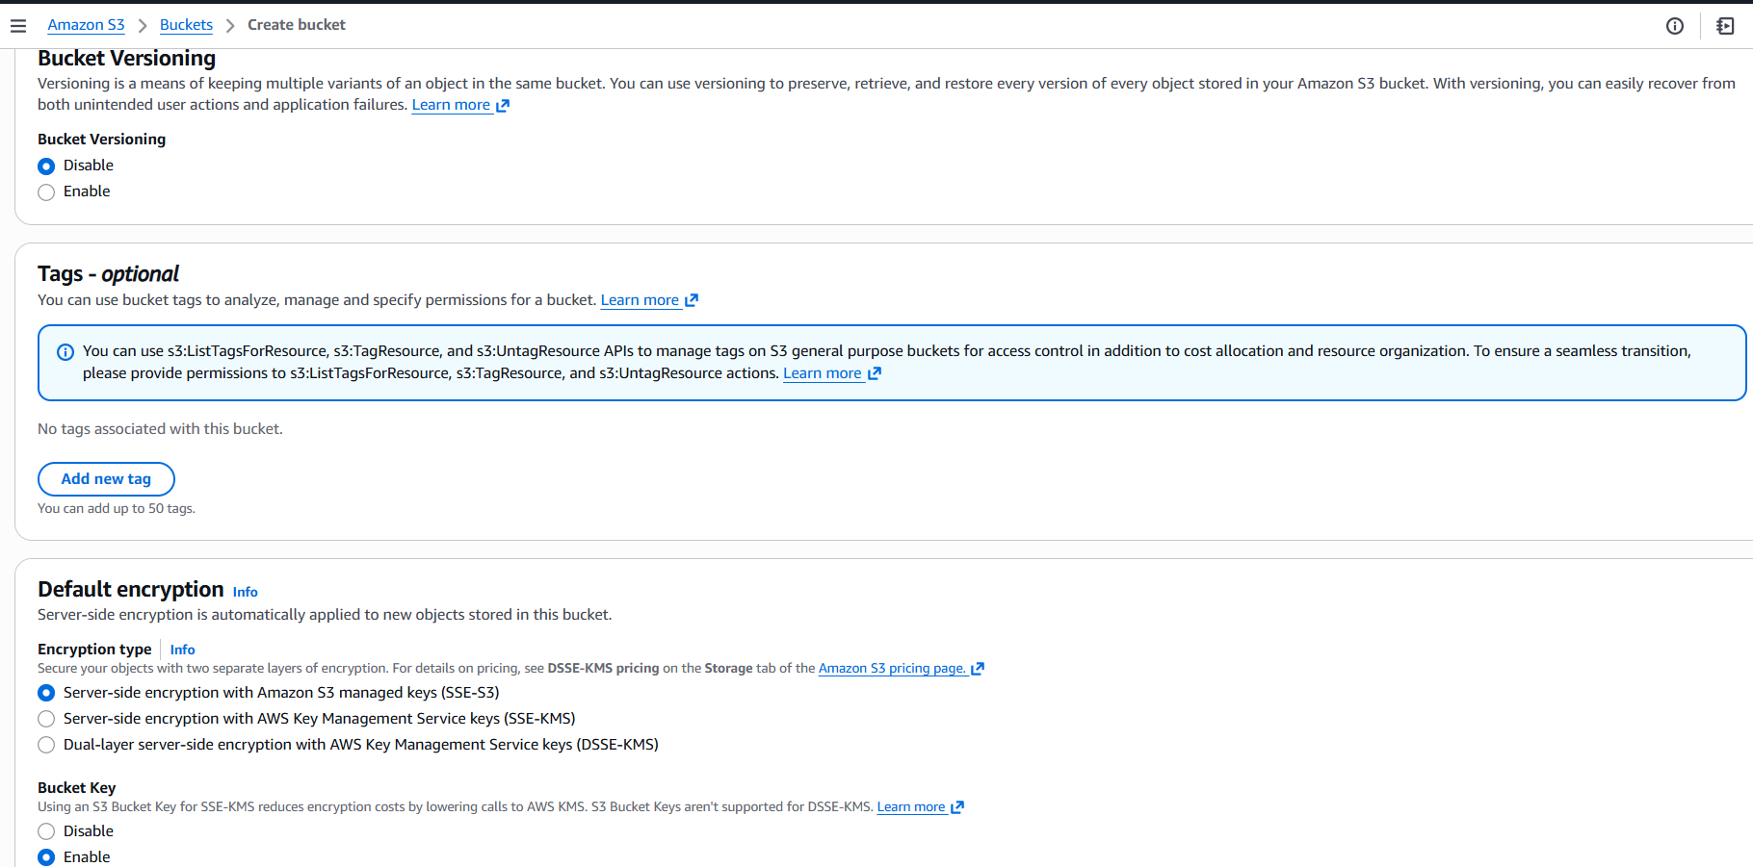

Bucket created successfully.

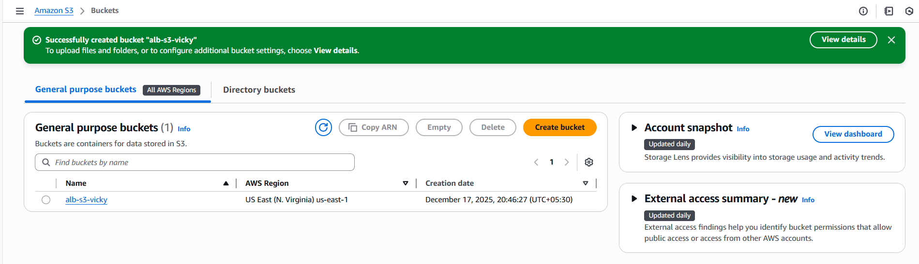

Now, we need to provide permissions to allow logs to be transferred from Application load balancer to S3.

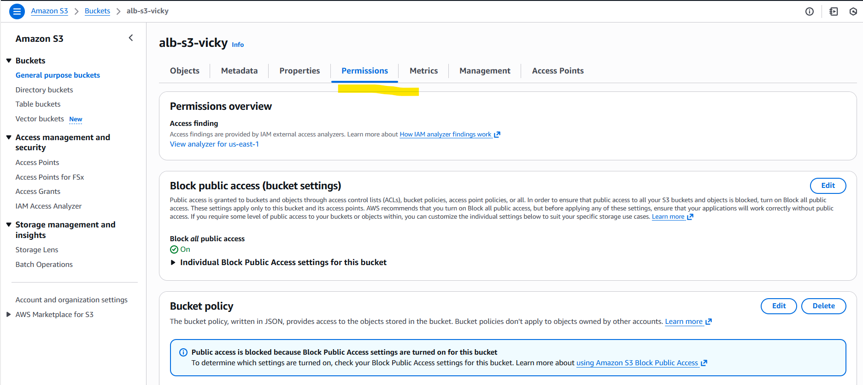Navigate to permissions tab and update json policy. The below is the policy attached.

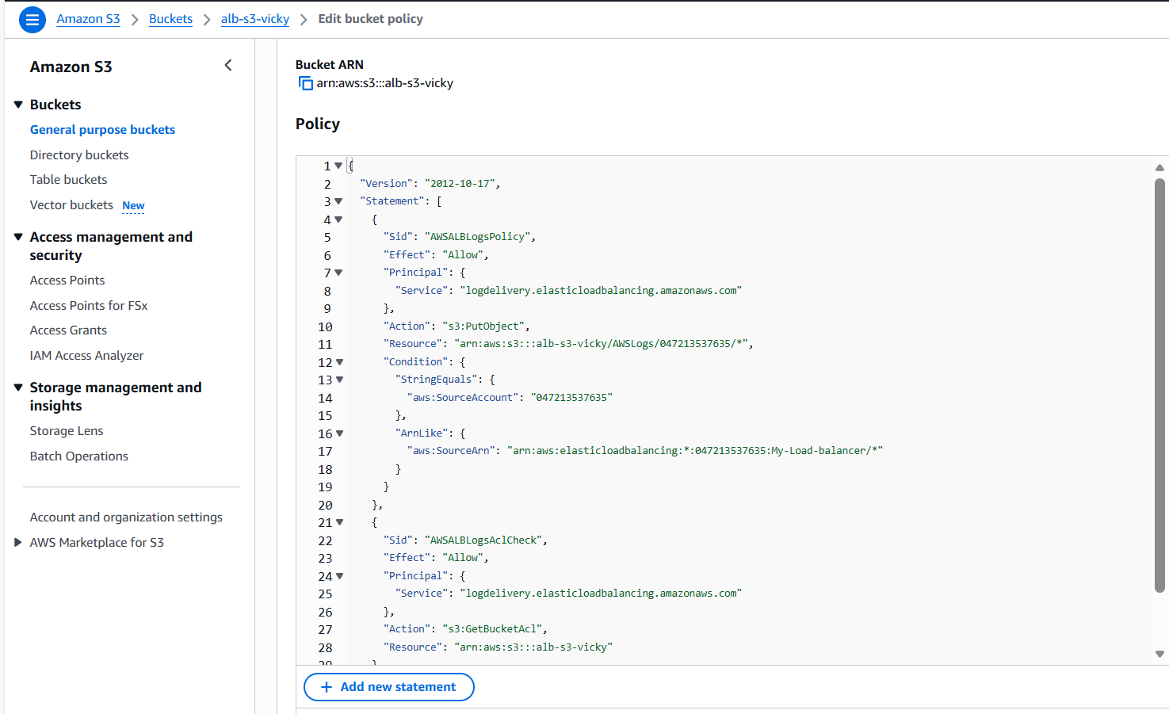

Navigate to Load balancer in Ec2 and select attributes tab and proceed

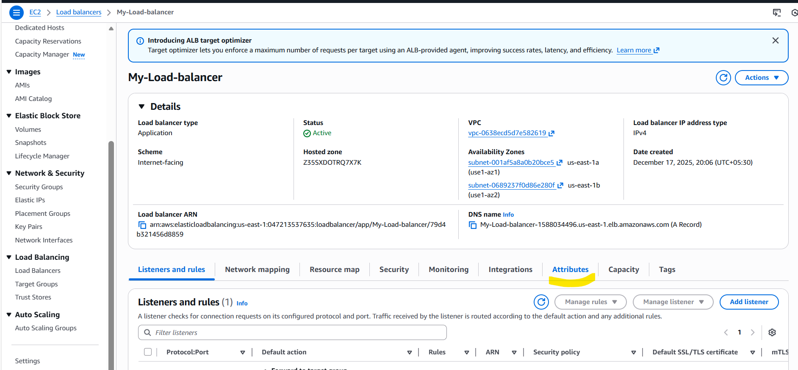

Next, scroll down below and select Monitoring 🡪access logs.

Since, there are no objects in s3, saving changes.

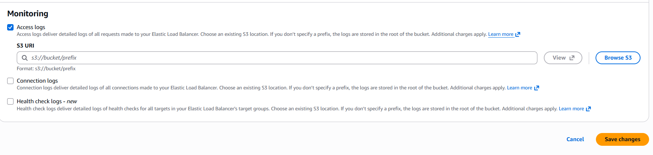

Finally, we can see the Load balancer is updated below.

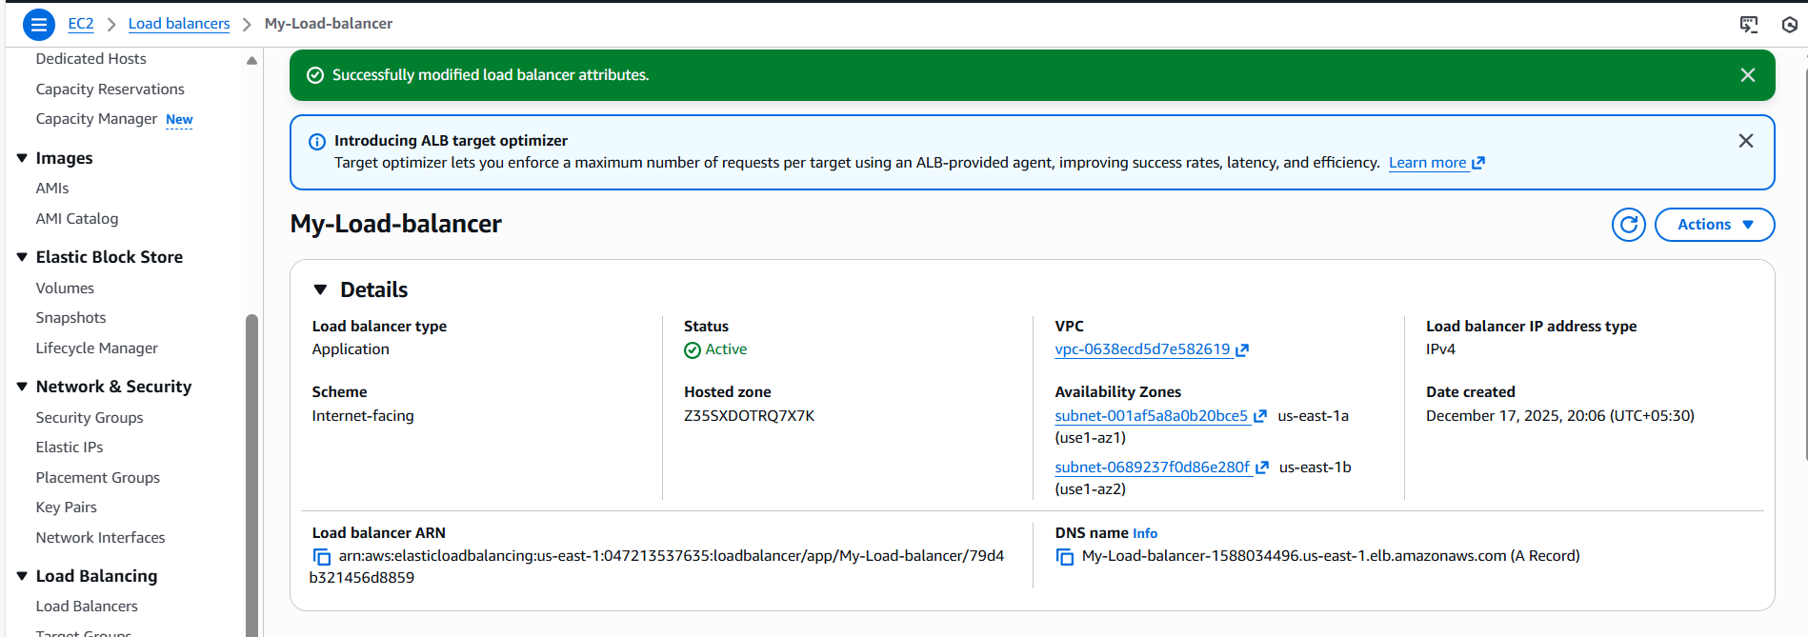

**10.Store the VPC flow logs in a CloudWatch log group:**

Navigate to VPC and create a flow log.

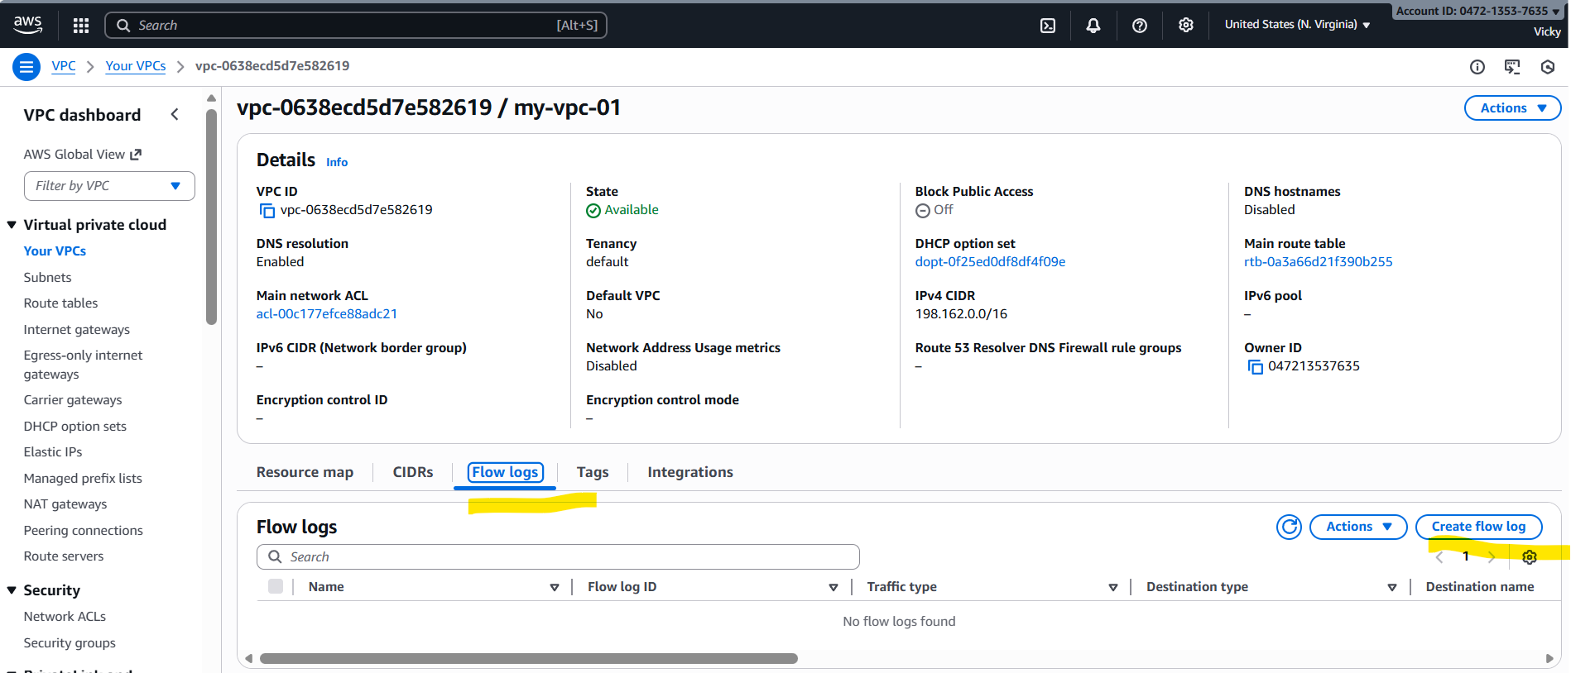

Filter: All

Interval: 1 Minute

Destination: Send to CloudWatch logs

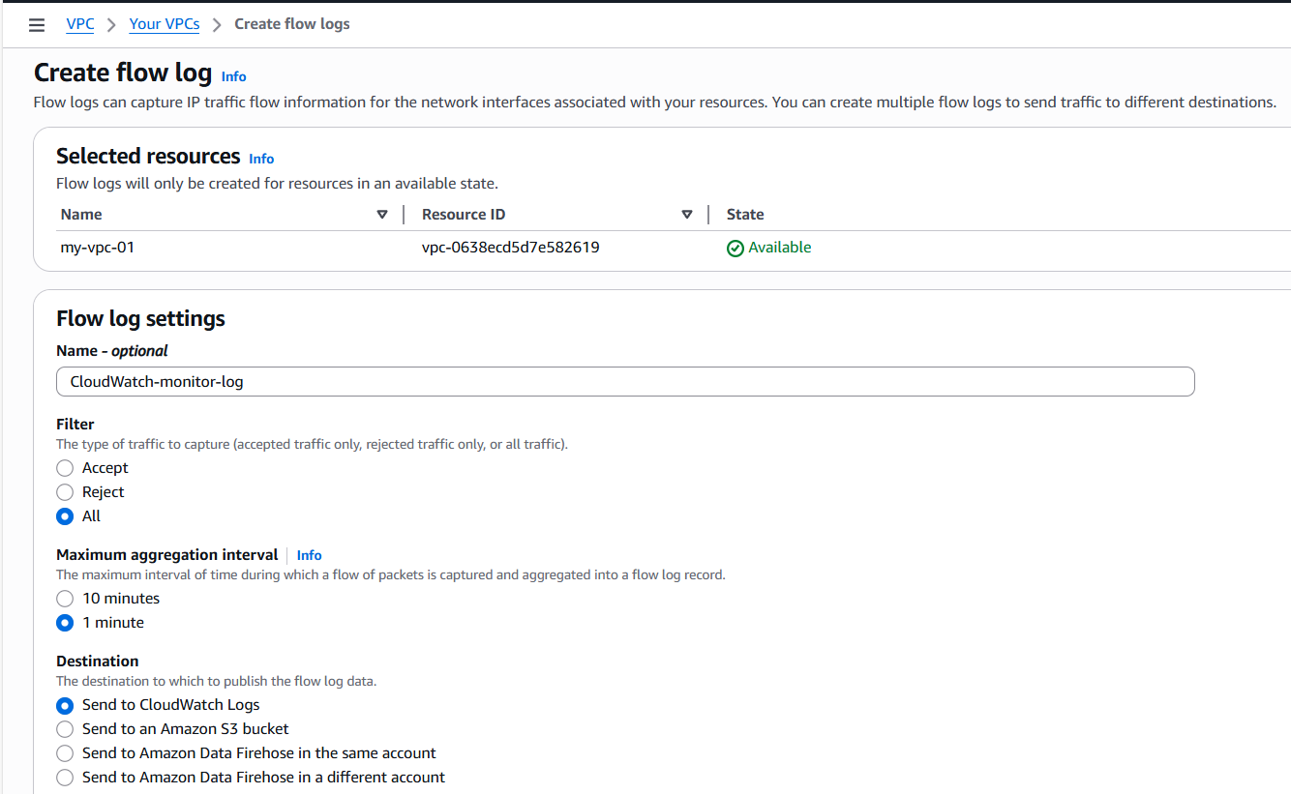

Destination log group: created a new one

Service role name: Created a new one and assigned automatically.

Continue next and create one.

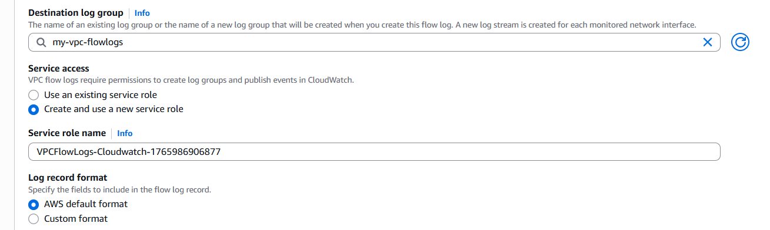

Created successfully.

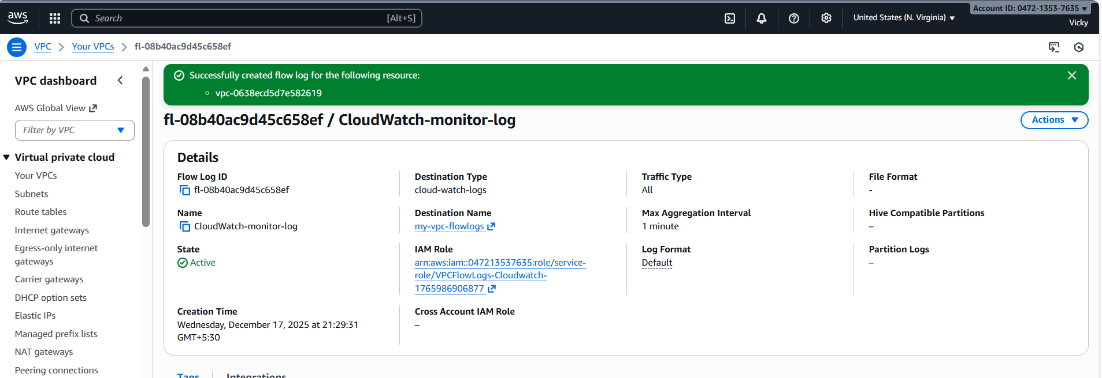

Now let’s navigate to CloudWatch and verify if the flow logs are created.

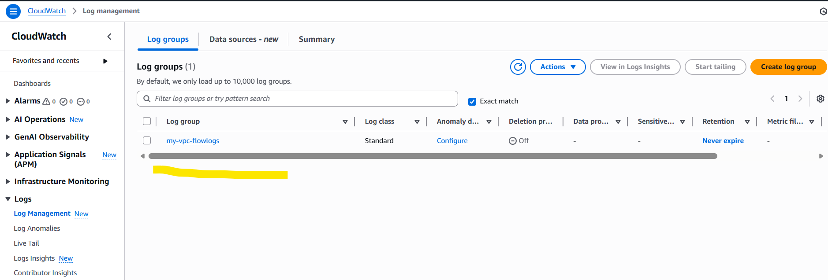

**11.Create monitoring dashboards to monitor CPU utilization and to monitor the Apache service:**

Navigate to CloudWatch andcreate a Dashboard in CloudWatch.

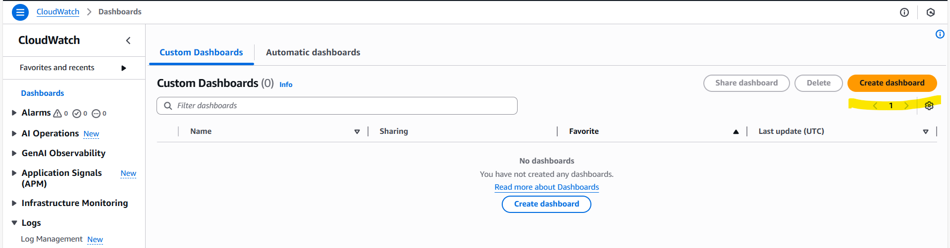

Select Number from the metrics

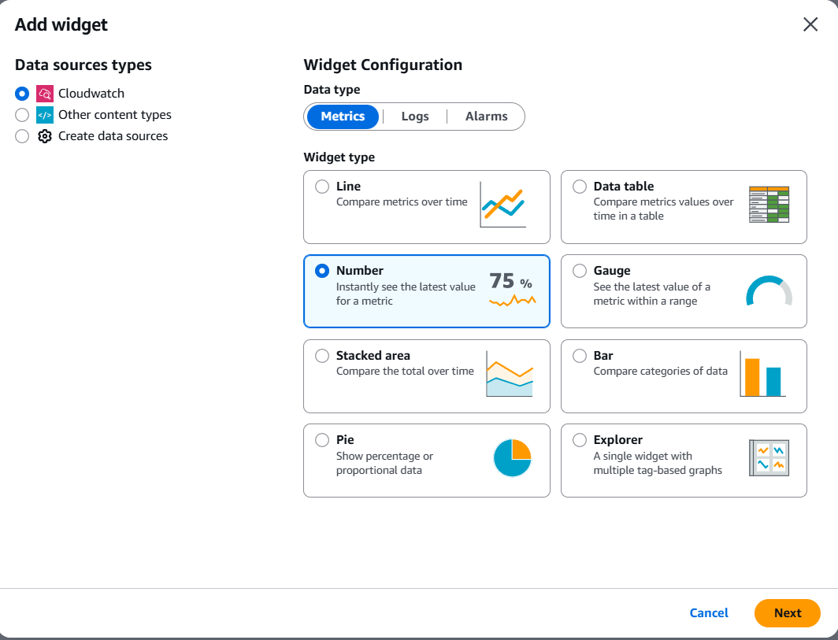

Select ec2 from the list below and filter from Per-Instance Metrics.

From the Per-Instance Metrics filter- CPU utilization.

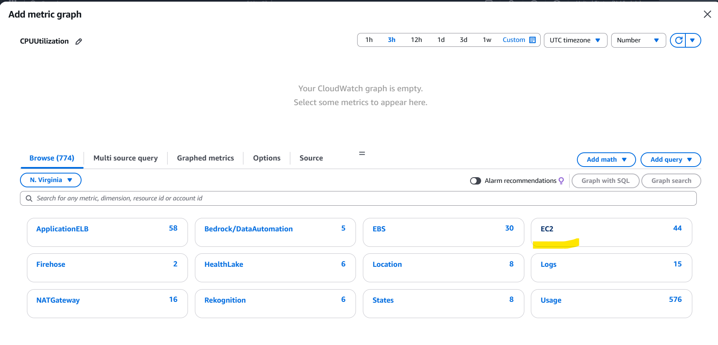

Selected public ec2 instance to monitor the CPU and Apache server.

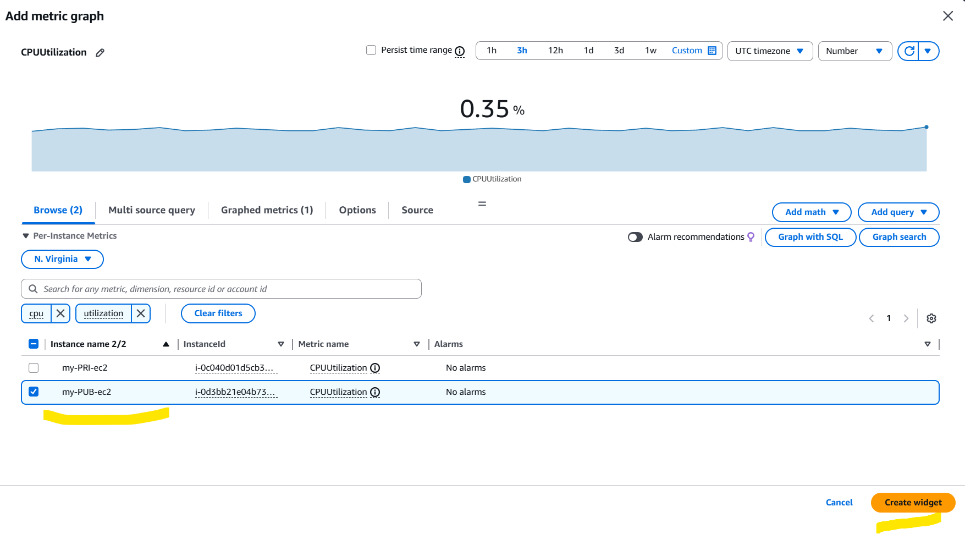

Dashboard created successfully.

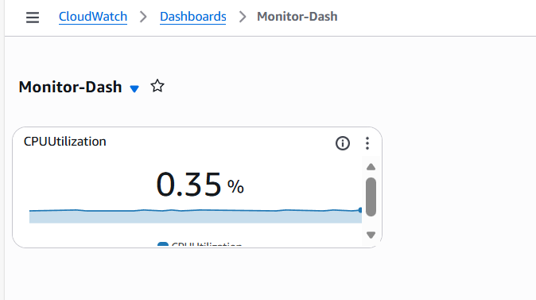

Create a new bash script to monitor the Apache service in CloudWatch

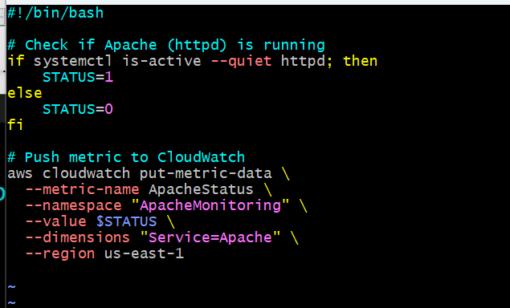

Using Cronjobs- I wan to run the script for every 5 minutes.

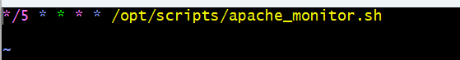

Using Cronjobs, enabled the script to un every 5 minutes and permissions provided.

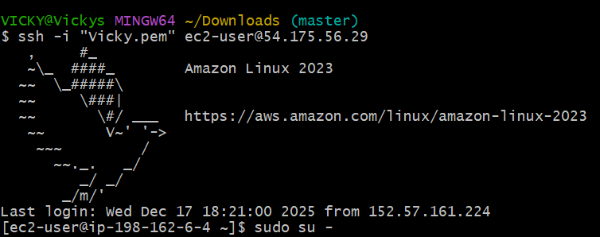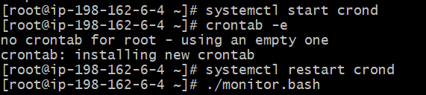

Now, it’s time to navigate to CloudWatch and add Apache to Dashboard.



